# Software Requirements Specifications (SRS)

## User Requirement Specification

The system has five actors including: guest, customer, staff, admin and system.

|  |  |
| --- | --- |
| **Actor** | **Description** |
| Guest | Person join to website but not login into system. |
| Customer | Person who want to rent offices and logged into system |
| Admin | Person who manage account and ban/ unban account |
| Manager | Person who manage request, contact customer, schedule staff…. |
| Staff | Person who in charge of create office, receive and process the appointment/ repair/ rental/ return office request |
| System | System will manage the schedule to process contract time, send notification, suggest office for customer |

Table : Overall user requirement specification

### Guest requirement

* **Register:** Guest need to register to become member of system.
* **Search office:** Customer can search suitable office by criteria such as price, location, name….
* **Login**: Guest uses email and password to login into the system to search or request office.

### Customer requirement

* **Search office:** Customer can search suitable office by criteria such as price, location, name….
* **Send request:** Customer can send request about book appointment, repair something in office, rental, and request cancel before expire…
* **Rate and comment office:** Customer can rate and comment satisfaction about office they renting.

### Admin requirement

* **Logout:** When finish all activities at website they can log out of system.
* **Manager member:** Admin can add, edit, remove or ban/ unban account.

### Manager requirement

* **Contact with customer:** Manager can notify customer when task is done.
* **Manager contract:** Manager can create, edit contract.
* **Monitor request:** Manager can confirm about request repair, rental, appointment.
* **Schedule staff:** manager can schedule staff to contact with customer when request has been approved by manager.

### Staff requirement

* **Logout:** When finish all activities at website they can log out of system.
* **Contact with customer:** staff have to check task list about the appointment with customer and change status of the appointment when finish his task.
* **Monitor office:** staff can add, edit or remove comment about office.
* **Repair amenities:** staff have to check task list about the request repair amenities and change status of that request after repair complete.

### System requirement

* **Send notification mail:** system will send notification mail to customer when appointment has been approved and scheduled or request repair has been accepted.
* **Send notification SMS (short message service):** system will send notification mail to customer when their contract will be expired in one month.
* **Suggest office:** system will suggest some offices which is nearly suitable with what customer searching.
* **Schedule request:** system will auto schedule all request about appointment and repair when those request has been approved by manager.

## System Requirement Specification

### External Interface Requirements

#### User Interfaces

* User interface must be friendly, simple.
* All functions should be showed clearly and don’t make user confuse.

#### Hardware Interfaces

* The system will use the standard hardware and data communications resources of a standard computer.

#### Software Interfaces

* The website run in Firefox and Chrome browsers.

#### Communications Protocol

* The website uses:
* HTTP/HTTPS protocol for communication between the web browser and the web server.
* TCP/IP network protocol for communication with HTTP protocol.
* WAP protocol for sending message for customer.

### System Overview Use Case:

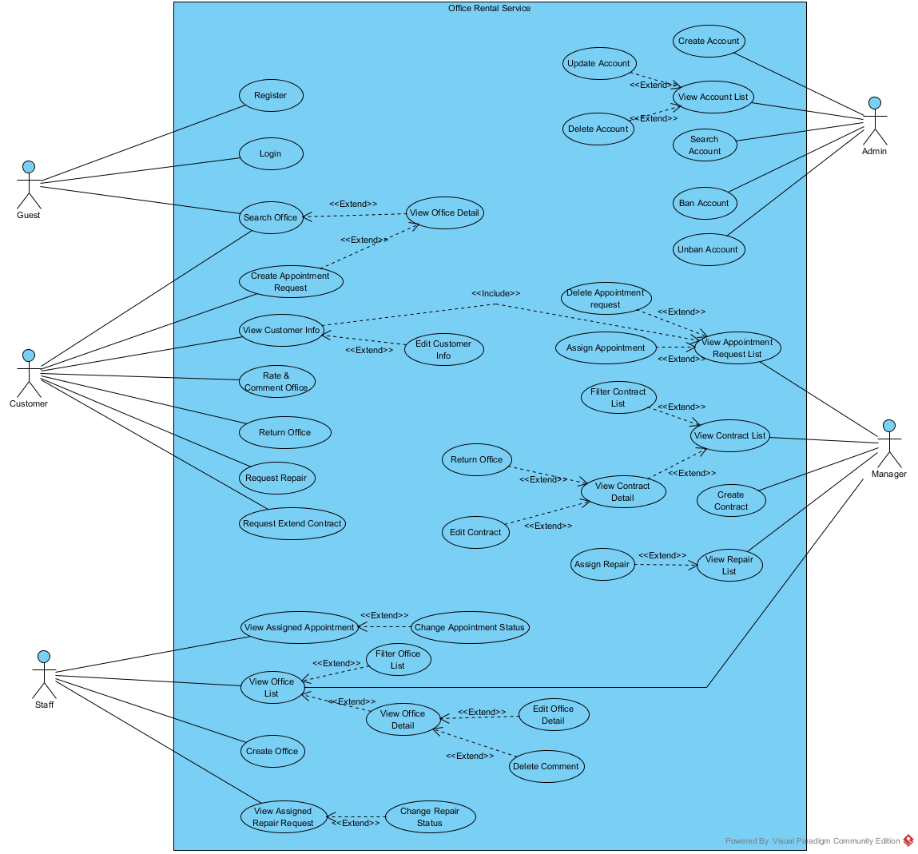

Figure : Use Case Overview

### List of Use Case:

#### <Guest>Overview Use Case

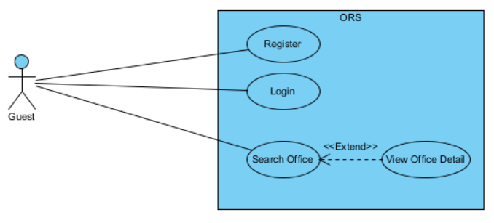

Figure : <Guest>Overview Use Case

##### <Guest> Register

**Use Case Diagram**

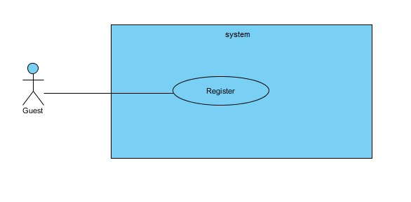

Figure : <Guest> Register

**Use Case Specification**

|  |  |  |  |  |
| --- | --- | --- | --- | --- |
| **USE CASE – REGISTER** | | | | |
| **Use-case No.** | UC011 | **Use-case Version** | | 1.0 |
| **Use-case Name** | Register | | | |
| **Author** | Trần Lê Tuấn | | | |
| **Date** | 01/06/2015 | **Priority** | Normal | |
| **Actor:**   * Guest   **Summary:**   * This use case allows guest create account.   **Goal:**   * Help guest to create new account.   **Trigger:**   * Click “Đăng ký” button.   **Pre-conditions:**   * User want to create new account   **Post conditions:**   * **Success**: The new account will be added into database. * **Failure**: Cannot create account. System displays error message on register page.   **Main Success Scenario:**   |  |  |  | | --- | --- | --- | | Step | Actor Action | System Response | | 1 | Click “Đăng ký” button | System redirect to [Register Page], contain a register form :   * Họ và tên: Textbox (min length: 6, max length: 50) * Tên đăng nhập:   In format: /^(\w+[\.])*\w+@@(\w+\.)+[a-zA-Z]+$/   * Địa chỉ Email: Textbox * Mật khẩu: Password Filed (min length: 8, max length: 20) * Xác nhận mật khẩu: Password Field (min length: 8, max length: 20) * Ngày sinh: Date time picker * Quận: Dropdownlist * Phường: Textbox * Số nhà/ đường: Textbox * Số điện thoại: Textbox (min length: 10, max length: 11)   In format: /^[0-9]*$/   * Đăng ký[ Register :button] * Xóa[Clear: button] | | 2 | Input information.  Clicks “Đăng ký” button. | [Exceptions 1,2 3,4,5,6]  Redirect to [Home Page] and displays popup:”Bạn đã đăng ký tài khoản thành công!”. |   **Alternative Scenario:**   |  |  |  | | --- | --- | --- | |  | Actor Action | System Response | | 1 | Click on the “Xóa trắng” button. | All information in register form is cleared. |   **Exceptions:**   |  |  |  | | --- | --- | --- | | No. | Actor Action | System Response | | 1 | “Họ và tên”, “Địa chỉ email”, “Mật khẩu”, “Xác nhận mật khẩu”, “Ngày sinh”, “Địa chỉ” are blank. | Display error message:” Vui lòng nhập đầy đủ thông tin yêu cầu!” | | 2 | Email is already exists. | Display error message:”Email này đã được sử dụng để đăng ký thành viên!” | | 3 | Password is less than 8 or more than 32 characters characters. | Display error message “Yêu cầu mật khẩu từ 8-32 kí tự!” | | 4 | Guest fills password and re-password different | Display error message” Mật khẩu nhập lại chưa chính xác !” | | 5 | Phone Number is not a number or less than 10 numbers or greater than 11 numbers. | Display error message “Số điện thoại không hợp lệ!” | | 6 | Full Name is less than 6 characters or greater than 50 characters. | Display error message “Vui lòng nhập tên từ 6 đến 50 ký tự!” |   **Relationships:** N/A  **Business Rules**:   * Username must be different from username of existed account of system. | | | | |

Table : <Guest> Register

##### <Guest> Login

**Use Case Diagram**

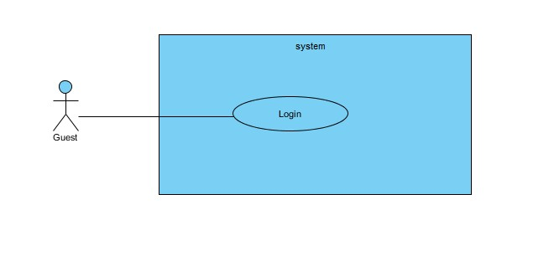

Figure : <Guest> Login

**Use Case Specification**

|  |  |  |  |  |
| --- | --- | --- | --- | --- |
| **USE CASE – LOGIN** | | | | |
| **Use-case No.** | UC012 | **Use-case Version** | | 2.0 |
| **Use-case Name** | Login | | | |
| **Author** | Trần Lê Tuấn | | | |
| **Date** | 25/05/2015 | **Priority** | Normal | |
| **Actor:**   * Guest   **Summary:**   * This use case allows user to login to system   **Goal:**   * User can login into system   **Triggers:**   * Click “Đăng nhập” button.   **Preconditions:**   * The member has already had an account of this system.   **Post Conditions:**   * **Success:** User successfully login into the system * **Failure:** User cannot login, error message is display   **Main Success Scenario:**   |  |  |  | | --- | --- | --- | | Step | Actor Action | System Response | | 1 | Click “Đăng nhập” button | Show [Login Page] with the login form:   * Tên đăng nhập: Textbox   In format: /^(\w+[\.])*\w+@@(\w+\.)+[a-zA-Z]+$/   * Mật khẩu: Password Filed (min length: 8, max length: 32) * Đăng Nhập: Button * Tạo tài khoản: Link * Quên mật khẩu: Link | | 2 | Input email and password.  Click on “Đăng Nhập” button.  [Alternative 1,2] | [Exceptions 1,2 3]  Save login session  Redirect to [Curent Page]. |   **Alternative Scenario:**   |  |  |  | | --- | --- | --- | |  | Actor Action | System Response | | 1 | Click on “Tạo tài khoản” link. | Redirect to Register page. | | 2 | Click on “Quên mật khẩu” link. | Redirect to ResetPassword page. |   **Exceptions:**   |  |  |  | | --- | --- | --- | | No. | Actor Action | System Response | | 1 | Email or Password textbox is empty. | Display error message “Vui lòng nhập đầy đủ thông tin địa chỉ email và mật khẩu!”. | | 2 | Email or Passowrd not correct. | Display error message “Email hoặc mật khẩu không chính xác, vui lòng thử lại!” | | 3 | Cannot login due to database connection | Display error message “Không thể đăng nhập. Vui lòng thử lại” |   **Relationships:** N/A  **Business Rules:**   * Customer can only login in [customer login] page * Staff and admin can only login in [staff login] page | | | | |

Table : <Guest> Login

##### <Guest, Customer> Search office

**Use Case Diagram**

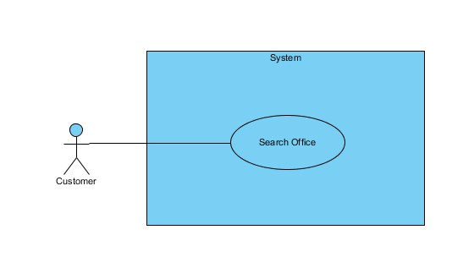

Figure : <Guest, Customer> Search office

**Use Case Specification**

|  |  |  |  |  |
| --- | --- | --- | --- | --- |
| **USE CASE – SEARCH OFFICE** | | | | |
| **Use-case No.** | UC013 | **Use-case Version** | | 2.0 |
| **Use-case Name** | Search office | | | |
| **Author** | Trần Lê Tuấn | | | |
| **Date** | 18/05/2015 | **Priority** | Normal | |
| **Actor:**   * Guest * Customer   **Summary:**   * This use case allows customer search office.   **Goal:**   * Customer can find success an office.   **Trigger:**   * Fill information in text fill or choice some available information. * Click “Tìm kiếm” in home page.   **Pre-conditions:**  **Post conditions:**   * **Success:** Search office successful. * **Fail:** Show message error and show which information error.   **Main Success Scenario:**   |  |  |  | | --- | --- | --- | | Step | Actor Action | System Response | | 1 | Fill information in home page. | Show error message or success message  Tên văn phòng: Textbox  Giá thuê: Dropdown list  Quận: Dropdown list  Thành phố: Dropdown list  Số người: Dropdown list | | 2 | Click “Tìm kiếm” button.  [Alternative 1] | [Exceptions 1]  Show result page. |   **Alternative Scenario:**   |  |  |  | | --- | --- | --- | |  | Actor Action | System Response | | 1 | Click to “Xoá trắng” button. | All information in register form is cleared. |   **Exceptions:**   |  |  |  | | --- | --- | --- | |  | Actor Action | System Response | | 1 | Cannot send request due to database connection | Show error message: “Không thể sửa thông tin, vui lòng thử lại sau.” |   **Relationships:** N/A  **Business Rules**: . | | | | |

Table : Search office

##### <Guest, Customer> View office detail

**Use Case Diagram**

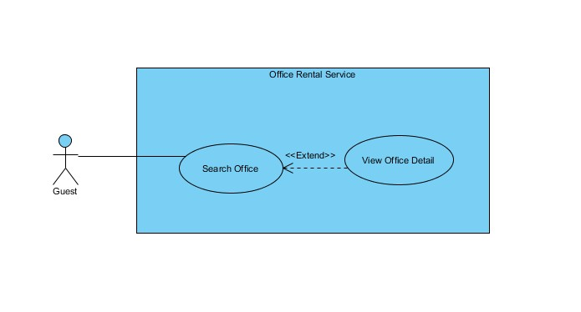

Figure : <Guest, Customer> View office detail

**Use Case Specification**

|  |  |  |  |  |
| --- | --- | --- | --- | --- |
| **USE CASE – VIEW OFFICE DETAIL** | | | | |
| **Use-case No.** | UC014 | **Use-case Version** | | 2.0 |
| **Use-case Name** | View Office Detail | | | |
| **Author** | Trần Lê Tuấn | | | |
| **Date** | 25/05/2015 | **Priority** | Normal | |
| **Actor:**   * Guest * Customer   **Summary:**   * This use case allows guest search office information.   **Goal:**   * Guest can search information.   **Triggers:**   * Fill information in the textbox or chose some suggest in search form. * Click “Tìm kiếm” button.   **Preconditions:**  **Post Conditions:**   * **Success**: Office result is showed successfully. * **Fail:** Cannot show office information.   **Main Success Scenario:**   |  |  |  | | --- | --- | --- | | Step | Actor Action | System Response | | 1 | Click on suggest offices. | Show office information include:  Tên văn phòng: Label.  Giới thiệu văn phòng: Text Area.  Quận: Label  Thành phố: Label  Số người: Label  Giá Thuê: Label  Thông tin thêm: Text Area.  [Exception 1] |   **Alternative Scenario:**   |  |  |  | | --- | --- | --- | | No. | Actor Action | System Response | |  |  |  |   **Exceptions:**   |  |  |  | | --- | --- | --- | | No. | Actor Action | System Response | | 1 | Cannot send request due to database connection | Show error message: “Không thể xem thông tin, vui lòng thử lại sau.” |   **Relationships:** Office  **Business Rules:** | | | | |

Table : <Guest, Customer> View office detail

#### <Customer>Overview Use Case

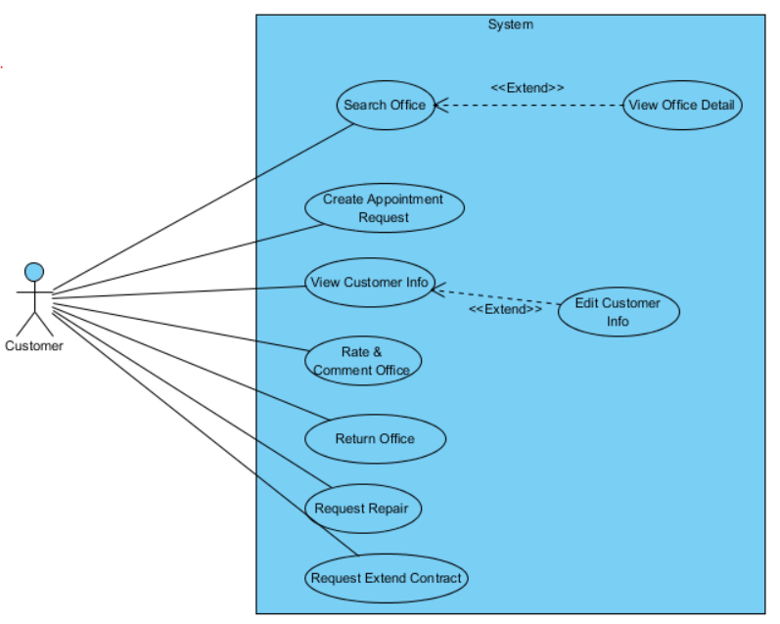

Figure : <Customer>Overview Use Case

##### <Customer> Create appointment request

**Use Case Diagram**

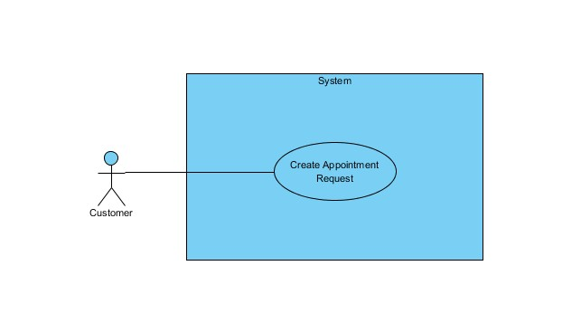

Figure : <Customer> Create appointment request

**Use Case Specification**

|  |  |  |  |  |
| --- | --- | --- | --- | --- |
| **USE CASE – CREATE APPOINTMENT REQUEST** | | | | |
| **Use-case No.** | UC021 | **Use-case Version** | | 2.0 |
| **Use-case Name** | Register | | | |
| **Author** | Trần Lê Tuấn | | | |
| **Date** | 18/09/2014 | **Priority** | Normal | |
| **Actor:**   * Customer   **Summary:**   * This use case allows customer request appointment   **Goal:**   * Customer can request appointment after they found suitable office   **Trigger:**   * Click to office which is suitable * Click “Đặt lịch hẹn” in office detail page   **Pre-conditions:**   * User must log in the system with Customer role. * Customer must have enough information (phone, address, name) to request appointment   **Post conditions:**   * **Success:** Request appointment successful. * **Fail:** Show message error and show which information error.   **Main Success Scenario:**   |  |  |  | | --- | --- | --- | | Step | Actor Action | System Response | | 1 | Click to office which suitable with customer | Open office detail :   * Tên văn phòng: Label * Thông tin văn phòng: Text area * Số điện thoại: Text * Đặt lịch hẹn: Button | |  | Click “Đặt lịch hẹn” button. | Show popup with required information of the customer: | | 3 | Input required information to popup | * Tên khách hàng: Textbox * Số điện thoại: Textbox * Email: Textbox * Tên yêu cầu: Textbox * Yêu cầu: Text area * Gửi: Button. * Xóa trắng: Button. | | 4 | Click “Gửi” button  [Alternative 1] | [Exception 1]  Show error message or success message |   **Alternative Scenario:**   |  |  |  | | --- | --- | --- | |  | Actor Action | System Response | | 1 | Click to “Xóa trắng” button. | All information in register form is cleared. |   **Exceptions:**   |  |  |  | | --- | --- | --- | |  | Actor action | System Response | | 1 | Cannot send request due to database connection | Show error message: “Không thể sửa thông tin, vui lòng thử lại sau.” |   **Relationships:** N/A  **Business Rules**:   * Customer can request appointment which offices have status available. | | | | |

Table : <Customer> Create appointment request

##### <Customer> View customer info

**Use Case Diagram**

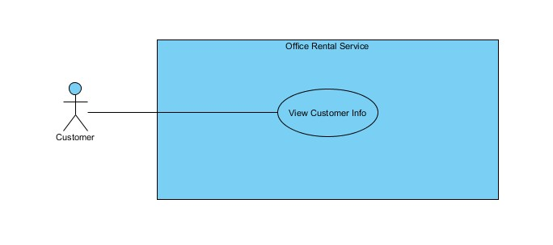

Figure : <Customer> View customer info

**Use Case Specification**

|  |  |  |  |  |
| --- | --- | --- | --- | --- |
| **USE CASE – EDIT CUSTOMER INFORMATION** | | | | |
| **Use-case No.** | UC002 | **Use-case Version** | | 2.0 |
| **Use-case Name** | View Customer Info | | | |
| **Author** | Trần Lê Tuấn | | | |
| **Date** | 25/05/2015 | **Priority** | Normal | |
| **Actor:**   * Customer   **Summary:**   * This use case allows customer view customer information.   **Goal:**   * Show successful customer information.   **Triggers:**   * Click “Thông tin cá nhân” in menu.   **Preconditions:**   * Customer must be login.   **Post Conditions:**   * **Success**: customer information is showed successfully. * **Fail:** Cannot view customer information.   **Main Success Scenario:**   |  |  |  | | --- | --- | --- | | Step | Actor Action | System Response | | 1 | Click “Thông tin cá nhân” on menu. | Show customer information  Display customer details includes:   * Họ và tên: Label * Tên đăng nhập: Label * Địa chỉ Email: Label * Giới tính: Label * Ngày sinh: Label * Địa chỉ: Label * Số điện thoại: Label   [Exception 1] |   **Alternative Scenario:**   |  |  |  | | --- | --- | --- | | No. | Actor Action | System Response | |  |  |  |   **Exceptions:**   |  |  |  | | --- | --- | --- | | No. | Actor Action | System Response | | 1 | Cannot view due to database connection | Show error message: “Không xem thông tin, vui lòng thử lại sau.” |   **Relationships:** Customer  **Business Rules:**   * Customer information must exist in database. | | | | |

Table : <Customer> View customer info

##### <Customer> Edit customer info

**Use Case Diagram**



Figure : <Customer> Edit customer info

**Use Case Specification**

|  |  |  |  |  |
| --- | --- | --- | --- | --- |
| **USE CASE – EDIT CUSTOMER INFORMATION** | | | | |
| **Use-case No.** | UC023 | **Use-case Version** | | 2.0 |
| **Use-case Name** | Edit customer information | | | |
| **Author** | Trần Lê Tuấn | | | |
| **Date** | 25/05/2015 | **Priority** | Normal | |
| **Actor:**   * Customer   **Summary:**   * This use case allows customer edit information.   **Goal:**   * Customer can edit information.   **Triggers:**   * Click “Thông tin cá nhân” in menu. * Click “Sửa thông tin cá nhân” submenu. * Fill information in the text box. * Click “Đồng ý” button.   **Preconditions:**   * Customer must be login.   **Post Conditions:**   * **Success**: customer information is edited successfully. * **Fail:** Cannot edit customer information.   **Main Success Scenario:**   |  |  |  | | --- | --- | --- | | Step | Actor Action | System Response | | 1 | Click “Thông tin cá nhân” on menu. | Show customer information  Display customer details includes:   * Họ và tên: Label * Tên đăng nhập: Label * Địa chỉ Email: Label * Giới tính: Label * Ngày sinh: Label * Địa chỉ: Label * Số điện thoại: Label | | 2 | Click “Sửa thông tin” on submenu. | Display office details includes:   * Họ và tên: Textbox (min length: 6, max length: 50) * Tên đăng nhập:   In format: /^(\w+[\.])*\w+@@(\w+\.)+[a-zA-Z]+$/   * Địa chỉ Email: Textbox * Mật khẩu: Password Filed (min length: 8, max length: 20) * Xác nhận mật khẩu: Password Field (min length: 8, max length: 20) * Giới tính: Dropdownlist * Ngày sinh: Date time picker * Quận: Dropdownlist * Phường: Textbox * Số nhà/ đường: Textbox * Số điện thoại: Textbox (min length: 10, max length: 11)   In format: /^[0-9]*$/   * Đồng ý[ OK :button] * Hủy[Cancel:button] | | 2 | Click “Đồng ý” button on screen.  [Alternative 1] | Show successful message “Sửa thông tin thành công” on screen.  [Exception 1] | |  |  |  |   **Alternative Scenario:**   |  |  |  | | --- | --- | --- | | No. | Actor Action | System Response | | 1 | Click “Huỷ” button. | Close rate office page and go to home page. |   **Exceptions:**   |  |  |  | | --- | --- | --- | | No. | Actor Action | System Response | | 1 | Cannot send request due to database connection | Show error message: “Không thể sửa thông tin, vui lòng thử lại sau.” |   **Relationships:** Member  **Business Rules:**   * Customer can edit information. | | | | |

Table : <Customer> Edit customer info

##### <Customer> Rate and comment office

**Use Case Diagram**

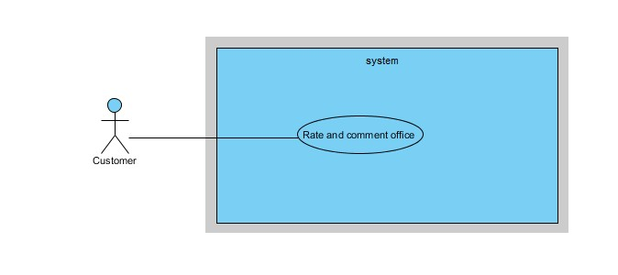

Figure : <Customer> Rate and comment office

**Use Case Specification**

|  |  |  |  |  |
| --- | --- | --- | --- | --- |
| **USE CASE – RATE AND COMMENT OFFICE** | | | | |
| **Use-case No.** | UC024 | **Use-case Version** | | 2.0 |
| **Use-case Name** | Rate and comment office | | | |
| **Author** | Trần Lê Tuấn | | | |
| **Date** | 25/05/2015 | **Priority** | Normal | |
| **Actor:**   * Customer   **Summary:**   * This use case allows customer rate and comment office.   **Goal:**   * Customer can rate and comment office.   **Triggers:**   * Click “Thông tin văn phòng” in menu. * Click “Đánh giá văn phòng” submenu. * Fill information in the text box. * Click “Gửi” button.   **Preconditions:**   * Customer must be login.   **Post Conditions:**   * **Success**: rate and comment office is sent successfully. * **Fail:** Cannot rate and comment office.   **Main Success Scenario:**   |  |  |  | | --- | --- | --- | | Step | Actor Action | System Response | | 1 | Click “Đánh giá văn phòng” on submenu. | Show page rate and comment  Display office details includes:   * Details of product: * Tên văn phòng: label * Địa chỉ: label * Email: textbox * Đánh giá : textbox   “Gửi” : button  “Huỷ” : button | | 2 | Click “Gửi” button on screen.  [Alternative 1] | Show successful message “Gửi đánh giá thành công” on screen.  [Exception 1] | |  |  |  |   **Alternative Scenario:**   |  |  |  | | --- | --- | --- | | No. | Actor Action | System Response | | 1 | Click “Huỷ” button. | Close rate office page and go to home page. |   **Exceptions:**   |  |  |  | | --- | --- | --- | | No. | Actor Action | System Response | | 1 | Cannot send request due to database connection | Show error message: “Không thể gửi đánh giá, vui lòng thử lại sau.” |   **Relationships:** Staff Member  **Business Rules:**   * Customer can send rate and comment office to staff. | | | | |

Table : <Customer> Rate and comment office

##### <Customer> Request return office (before due)

**Use Case Diagram**

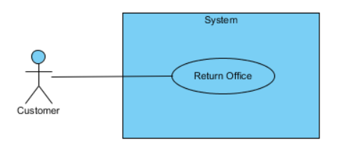

Figure : <Customer> Request return office

**Use Case Specification**

|  |  |  |  |  |
| --- | --- | --- | --- | --- |
| **USE CASE – REQUEST RETURN OFFICE (BEFORE DUE)** | | | | |
| **Use-case No.** | UC025 | **Use-case Version** | | 2.0 |
| **Use-case Name** | Request return office (before due) | | | |
| **Author** | Trần Lê Tuấn | | | |
| **Date** | 25/05/2015 | **Priority** | Normal | |
| **Actor:**   * Customer   **Summary:**   * This use case allows customer to send request cancel to manager.   **Goal:**   * Customer can send request cancel to manager successful.   **Triggers:**   * Click “Thông tin văn phòng” in menu. * Click “Gửi yêu cầu hủy hợp đồng” submenu. * Fill information in the text box. * Click “Gửi” button.   **Preconditions:**   * Customer must have an avaiable contract.   **Post Conditions:**   * **Success**: request cancel is sent successfully. * **Fail:** Cannot send request cancel.   **Main Success Scenario:**   |  |  |  | | --- | --- | --- | | Step | Actor Action | System Response | | 1 | Click “Gửi yêu cầu trả văn phòng trước hạn” on submenu. | Show page create request  Display office details includes:   * Details of request: * Tên yêu cầu: textbox * Địa chỉ: label * Email: textbox * Yêu cầu : textbox   “Gửi” : button  “Huỷ” : button | | 2 | Click “Gửi” button on screen.  [Alternative 1] | Show successful message “Gửi yêu cầu thành công.” on screen.  [Exception 1] | |  |  |  |   **Alternative Scenario:**   |  |  |  | | --- | --- | --- | | No. | Actor Action | System Response | | 1 | Click “Huỷ” button. | Close request page and go to home page. |   **Exceptions:**   |  |  |  | | --- | --- | --- | | No. | Actor Action | System Response | | 1 | Cannot send request due to database connection | Show error message: “Không thể gửi yêu cầu, vui lòng thử lại sau.” |   **Relationships:** Contract Customer  **Business Rules:**   * Customer can send request to manager. * Request must be approved by manager. | | | | |

Table : <Customer> Request return office

##### <Customer> Request repair

**Use Case Diagram**

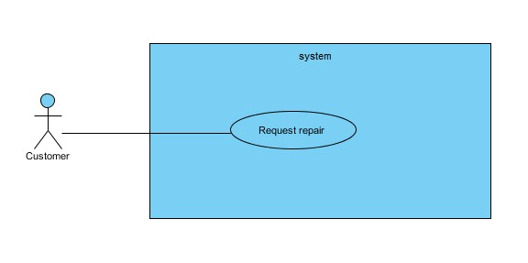

Figure : <Customer> Request repair

**Use Case Specification**

|  |  |  |  |  |
| --- | --- | --- | --- | --- |
| **USE CASE – REQUEST REPAIR** | | | | |
| **Use-case No.** | UC026 | **Use-case Version** | | 2.0 |
| **Use-case Name** | Request repair | | | |
| **Author** | Trần Lê Tuấn | | | |
| **Date** | 25/05/2015 | **Priority** | Normal | |
| **Actor:**   * Customer   **Summary:**   * This use case allows customer to send request repair to manager.   **Goal:**   * Customer can send request repair to manager successful.   **Triggers:**   * Click “Thông tin văn phòng” in menu. * Click “Gửi yêu cầu sửa chữa” submenu. * Fill information in the text box. * Click “Gửi” button.   **Preconditions:**   * Customer can send request repair to manage.   **Post Conditions:**   * **Success**: request repair is sent successfully. * **Fail:** Cannot send request repair   **Main Success Scenario:**   |  |  |  | | --- | --- | --- | | Step | Actor Action | System Response | | 1 | Click “Gửi yêu cầu sửa chữa” on submenu. | Show page create request  Display office details includes:   * Details of request: * Tên yêu cầu: textbox * Loại yêu cầu: dropdownlist * Địa chỉ: label * Email: textbox * Yêu cầu : textbox   “Gửi” : button  “Huỷ” : button | | 2 | Click “Gửi” button on screen.  [Alternative 1] | Show successful message “Gửi yêu cầu thành công.” on screen.  [Exception 1] | |  |  |  |   **Alternative Scenario:**   |  |  |  | | --- | --- | --- | | No. | Actor Action | System Response | | 1 | Click “Huỷ” button. | Close request page and go to home page. |   **Exceptions:**   |  |  |  | | --- | --- | --- | | No. | Actor Action | System Response | | 1 | Cannot send request due to database connection | Show error message: “Không thể gửi yêu cầu, vui lòng thử lại sau.” |   **Relationships:** Manage Member  **Business Rules:**   * Customer can send request to manager. * Request must be approved by manager. | | | | |

Table : <Customer> Request repair

##### <Customer> Request extend contract

**Use Case Diagram**

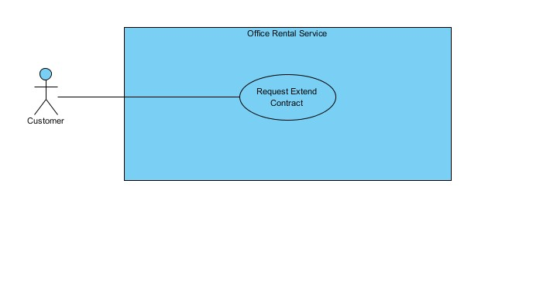

Figure : <Customer> Request extend contract

**Use Case Specification**

|  |  |  |  |  |
| --- | --- | --- | --- | --- |
| **USE CASE – REQUEST EXTEND CONTRACT** | | | | |
| **Use-case No.** | UC027 | **Use-case Version** | | 2.0 |
| **Use-case Name** | Request Extend Contract | | | |
| **Author** | Trần Lê Tuấn | | | |
| **Date** | 25/05/2015 | **Priority** | Normal | |
| **Actor:**   * Customer   **Summary:**   * This use case allows customer edit information.   **Goal:**   * Customer can edit information.   **Triggers:**   * Click “Thông tin hợp đồng” in menu. * Click “Gia hạn hợp đồng” submenu. * Fill information in the text box. * Click “Gửi” button.   **Preconditions:**   * Customer must be login. * Contract information must exist in database   **Post Conditions:**   * **Success**: Customer send request successfully. * **Fail:** Cannot send request.   **Main Success Scenario:**   |  |  |  | | --- | --- | --- | | Step | Actor Action | System Response | | 1 | Click “Thông tin hợp đồng” on menu. | Show page rate and comment  Display office details includes:   * Details of product: * Tên văn phòng: label * Địa chỉ: label * Email: textbox * Tên yêu cầu : textbox * Nội dung yêu cầu : text area   “Gửi” : button  “Xoá trắng” : button | | 2 | Fill information in page. |  | | 3 | Click “Gửi” button on screen.  [Alternative 1] | Show successful message “Gửi yêu cầu thành công” on screen.  [Exception 1] | |  |  |  |   **Alternative Scenario:**   |  |  |  | | --- | --- | --- | | No. | Actor Action | System Response | | 1 | Click “Xoá trắng” button. | All information in request form is cleared. |   **Exceptions:**   |  |  |  | | --- | --- | --- | | No. | Actor Action | System Response | | 1 | Cannot send request due to database connection | Show error message: “Không thể gửi yêu cầu, vui lòng thử lại sau.” |   **Relationships:** Customer Contract  **Business Rules:**   * Contract information must exist in database. | | | | |

Table : <Customer> Request extend contract

#### <Staff> Overview Use Case

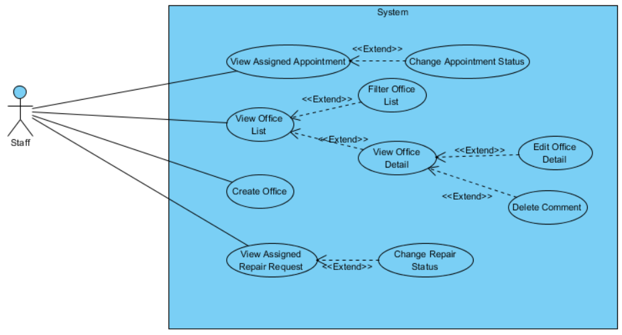

Figure : <Staff> Overview Use Case

##### <Staff>View Assigned Appointment

**Use Case Diagram**

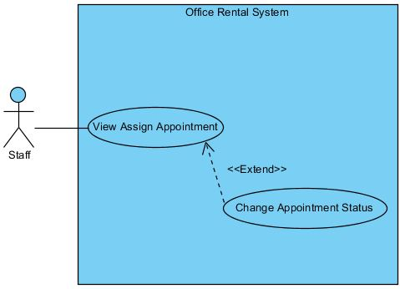

Figure : <Staff>View Assigned Appointment

**Use Case Specification**

|  |  |  |  |
| --- | --- | --- | --- |
| **USE CASE VIEW ASSIGNED APPOINTMENT** | | | |
| **Use Case No.** | UC031 | **Use Case Version** | 1.0 |
| **Use Case Name** | View Assigned Appointment | | |
| **Author** | Trương Tiến Thành | | |
| **Date** | 29/05/2015 | **Priority** | High |
| **Actor:**   * Staff   **Summary:**   * This use case allows staff to view time to meet customer at the office they want to rent.   **Goal:**   * Staff can view time to meet customer.   **Triggers:**   * Click “Xem công việc” in menu. * Choose “Lịch gặp khách hàng” in drop down menu.   **Preconditions:**   * User must log in the system with Staff role.   **Post Conditions:**   * **Success:** Display appointment list. * **Fail:** Cannot load appointment list.   **Main Success Scenario:**   |  |  |  | | --- | --- | --- | | Step | Actor Action | System Response | | 1 | Choose “Lịch gặp khách hàng” in drop down menu at staff page. | Display all appointment with status.  [Alternative 1] [Exception 1] |   **Alternative Scenario:**   |  |  |  | | --- | --- | --- | | No | Actor Action | System Response | | 1 | Choose “Lịch gặp khách hàng” in drop down menu at staff page. | Display message: “Không có lịch gặp khách hàng.” |   **Exceptions:**   |  |  |  | | --- | --- | --- | | No | Actor Action | System Response | | 1 | Cannot view list appointment to database connection. | Display error message: “Không thể tải lịch gặp khách hàng. Vui lòng thử lại sau.” |   **Relationships:** Change Appointment Status  **Business Rules:**   * List of appointment is sorted by status with the status “Incomplete” on top of list. | | | |

Table : <Staff>View Assigned Appointment

##### <Staff> Change Appointment Status

**Use Case Diagram**

**

Figure : <Staff>View Assigned Appointment

**Use Case Specification**

|  |  |  |  |
| --- | --- | --- | --- |
| **USE CASE CHANGE APPOINTMENT STATUS** | | | |
| **Use Case No.** | UC032 | **Use Case Version** | 1.0 |
| **Use Case Name** | Change Appintment Status | | |
| **Author** | Trương Tiến Thành | | |
| **Date** | 29/05/2015 | **Priority** | High |
| **Actor:**   * Staff   **Summary:**   * This use case allows staff to change status of appointment when they finish meeting customer at office.   **Goal:**   * Staff change status from incomplete to complete.   **Triggers:**   * Click “Xem công việc” in menu. * Choose “Lịch gặp khách hàng” in drop down menu. * Click “Hoàn thành” button.   **Preconditions:**   * User must log in the system with Staff role. * Staff can change status after they meet customer. * At least there is one appointment with customer.   **Post Conditions:**   * **Success:** Appointment’s status is changed to “Hoàn thành”. * **Fail:** Appointment’s status isn’t updated in database.   **Main Success Scenario:**   |  |  |  | | --- | --- | --- | | Step | Actor Action | System Response | | 1 | On appointment page, clicks “Hoàn thành” button next to the appointment that he/she finished. | Display message “Đã thay đổi trang thái sang hoàn thành.”  [Exception 1] |   **Alternative Scenario:** N/A  **Exceptions:**   |  |  |  | | --- | --- | --- | | No | Actor Action | System Response | | 1 | Cannot change status due to database connection. | Display error message: “Không thể thay đổi trang thái. Vui lòng thử lại sau.” |   **Relationships:** View Assigned Appointment.  **Business Rules:**   * Cannot change status “Hoàn thành” to “Chưa hoàn thành”. * Staff should notify to manage before change status. | | | |

Table : <Staff>View Assigned Appointment

##### <Staff, Manager>View Office List

**Use Case Diagram**

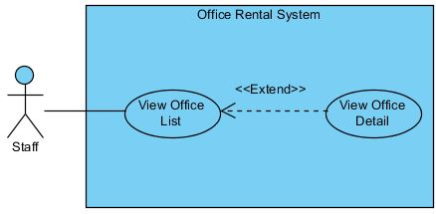

Figure : <Staff, Manager>View office list

**Use Case Specification**

|  |  |  |  |
| --- | --- | --- | --- |
| **USE CASE VIEW OFFICE LIST** | | | |
| **Use Case No.** | UC033 | **Use Case Version** | 1.0 |
| **Use Case Name** | View Office List | | |
| **Author** | Trương Tiến Thành | | |
| **Date** | 28/05/2015 | **Priority** | Normal |
| **Actor:**   * Staff, Manager   **Summary:**   * This use case allows staff or manager to view a lot of office by list.   **Goal:**   * Staff or manager can view list of office.   **Triggers:**   * Click “Xem văn phòng” in menu.   **Preconditions:**   * User must log in the system with Staff role.   **Post Conditions:**   * **Success:** Display list of office. * **Fail:** Cannot load list of office.   **Main Success Scenario:**   |  |  |  | | --- | --- | --- | | Step | Actor Action | System Response | | 1 | Click “Xem văn phòng” in menu at staff page. | Display all office by list.  [Alternative 1] [Exception 1] |   **Alternative Scenario:**   |  |  |  | | --- | --- | --- | | No | Actor Action | System Response | | 1 | Click “Xem văn phòng” in menu at staff page. | Display message: “Không có văn phòng nào.” |   **Exceptions:**   |  |  |  | | --- | --- | --- | | No | Actor Action | System Response | | 1 | Cannot view list of office due to database connection. | Display error message: “Không thể tải danh sách văn phòng. Vui lòng thử lại sau.” |   **Relationships:** View office detail, Filter office list  **Business Rules:**   * List of office is sorted by date with the newest date on top of list. * User can filter by status or district. | | | |

Table : <Staff, Manager>List of Office

##### <Staff, Manager>View Office Detail

**Use Case Diagram**

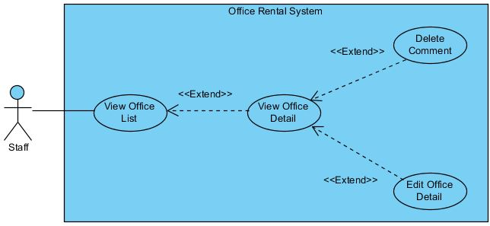

Figure : <Staff, Manager>View office detail

**Use Case Specification**

|  |  |  |  |
| --- | --- | --- | --- |
| **USE CASE VIEW OFFICE DETAIL** | | | |
| **Use Case No.** | UC034 | **Use Case Version** | 1.0 |
| **Use Case Name** | View Office Detail | | |
| **Author** | Trương Tiến Thành | | |
| **Date** | 28/05/2015 | **Priority** | Normal |
| **Actor:**   * Staff, manager   **Summary:**   * This use case allows staff or manager to view information of office.   **Goal:**   * Staff or manager can view information of office.   **Triggers:**   * Click “Xem văn phòng” in menu. * Click “Xem chi tiết văn phòng” button.   **Preconditions:**   * User must log in the system with Staff role. * At least there is one office in database.   **Post Conditions:**   * **Success:** Display detail information of office. * **Fail:** Cannot load information of office.   **Main Success Scenario:**   |  |  |  | | --- | --- | --- | | Step | Actor Action | System Response | | 1 | Click “Xem chi tiết văn phòng” button next to the office that user want to view. | Display office detail page.  [Exception 1] |   **Alternative Scenario:** N/A  **Exceptions:**   |  |  |  | | --- | --- | --- | | No | Actor Action | System Response | | 1 | Cannot view detail of office due to database connection. | Display error message: “Không thể tải trang chi tiết văn phòng. Vui lòng thử lại sau.” |   **Relationships:** View Office List, Edit Office Detail, Delete Comment.  **Business Rules:**   * The display is different from the customer view | | | |

Table : <Staff, Manager>View Office Detail

##### <Staff> Delete Comment

**Use Case Diagram**

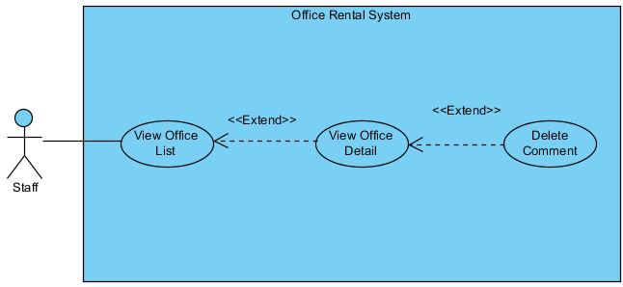

Figure : <Staff>Delete Comment

**Use Case Specification**

|  |  |  |  |
| --- | --- | --- | --- |
| **USE CASE DELETE COMMENT** | | | |
| **Use Case No.** | UC035 | **Use Case Version** | 1.0 |
| **Use Case Name** | Delete Comment | | |
| **Author** | Trương Tiến Thành | | |
| **Date** | 30/05/2015 | **Priority** | Normal |
| **Actor:**   * Staff   **Summary:**   * This use case is used to remove comment.   **Goal:**   * Staff can remove comment of customer.   **Triggers:**   * Click “Xem văn phòng” in menu. * Click “Xem chi tiết văn phòng” button. * Click “Xóa bình luận” button.   **Preconditions:**   * User must be logged in the system with Staff role. * At least there is one comment.   **Post Conditions:**   * **Success:** Remove comment successful. * **Fail:** Can’t remove comment.   **Main Success Scenario:**   |  |  |  | | --- | --- | --- | | Step | Actor Action | System Response | | 1 | Click “Xóa bình luận” button of comment that he/she wants to remove. | Show popup:   * “Bạn muốn xóa bình luận này?”. * “Có” button. * “Không” button. | | 2 | Click on “Có” button.  [Alternative 1] | Remove comment from database.  Show popup:   * “Đã xóa thành công” message. * “Đóng” button.   [Exception 1] | | 3 | Click on “Đóng” button. | Close current popup. |   **Alternative Scenario:**   |  |  |  | | --- | --- | --- | | No | Actor Action | System Response | | 1 | Click on “Không” button. | Close current popup. |   **Exceptions:**   |  |  |  | | --- | --- | --- | | No | Actor Action | System Response | | 1 | Cannot remove comment due to database connection | Display error message: “Không thể xóa bình luận này. Vui lòng thử lại sau.” |   **Relationships:** View Office Detail  **Business Rules:**   * Only remove spam comment. | | | |

Table : <Staff>Delete Comment

##### <Staff, Manager>Edit Office Detail

**Use Case Diagram**

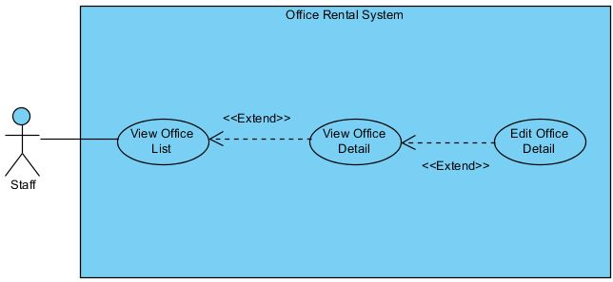

Figure : <Staff, Manager>Edit Office Detail

**Use Case Specification**

|  |  |  |  |
| --- | --- | --- | --- |
| **USE CASE EDIT OFFICE DETAIL** | | | |
| **Use Case No.** | UC036 | **Use Case Version** | 1.0 |
| **Use Case Name** | Edit Office Detail | | |
| **Author** | Trương Tiến Thành | | |
| **Date** | 28/05/2015 | **Priority** | Normal |
| **Actor:**   * Staff, Manager   **Summary:**   * This use case is used to edit information of office.   **Goal:**   * Staff or manager can edit information of a office.   **Triggers:**   * Click “Xem văn phòng” in menu. * Click “Xem chi tiết văn phòng” button. * Click “Cập nhật văn phòng” button   **Preconditions:**   * User must be logged in the system with Staff/Manager role. * At least there is one office in database.   **Post Conditions:**   * **Success:** New information of office is updated. * **Fail:** Cannot update information of office.   **Main Success Scenario:**   |  |  |  | | --- | --- | --- | | Step | Actor Action | System Response | | 1 | Clicks “Cập nhật văn phòng” button on the row of office that he/she wants to edit. | Redirect to update office page. It includes:   * Tên văn phòng: Text box (Name, length [3, 50], required)   [Exception 2]   * Địa chỉ: Text box (Address, min length: 6, required). * Quận: Drop down list (District, required) * Hình ảnh: Button (Image] * Trạng thái: Drop down list (Status, required) * Mô tả văn phòng: Text area (Description, length [3, 500], required)   [Exception 3]   * Giá thuê: Text box (Price, type number, required)   [Exception 4]   * Đơn vị giá: Drop down list (PriceTerm, require) * Số tầng: Text box (Floor, type number, required)   [Exception 5]   * Loại văn phòng: Drop down list (Category, required) * Tiện ích: Check box (Amenity) * Tổng diện tích: Text box (Area, type number, min length: 50, required)   [Exception 6, 7]   * Cập nhật: button   [Exception 1, 8]   * Hủy: button | | 3 | Edit information and clicks on “Cập nhật” button.  [Alternative 1] | Show popup:   * “Cập nhập thành công” message. * “Đóng” button | | 4 | Clicks on “Đóng” button | Redirect to office detail page. |   **Alternative Scenario:**   |  |  |  | | --- | --- | --- | | No | Actor Action | System Response | | 1 | Clicks on “Hủy” button | Redirect to office detail page. |   **Exceptions:**   |  |  |  | | --- | --- | --- | | No | Actor Action | System Response | | 1 | Cannot update office. | Shows error message “Không thể cập nhật văn phòng. Vui lòng thử lại sau” | | 2 | Name is less than 3 characters or more than 50 characters. | Shows error message “Tên văn phòng từ 3 đến 50 ký tự!”. | | 3 | Description is less than 3 characters or more than 500 characters. | Shows error message “Mổ tả văn phòng từ 3 đến 500 ký tự!”. | | 4 | Price is not a number. | Shows error message “Giá thuê không hợp lệ!” | | 5 | Floor is not a number. | Shows error message “Số tầng không hợp lệ!” | | 6 | Area is smaller than 50. | Shows error message “Tổng diện tích tối thiểu cho thuê là 50m2!” | | 7 | Area is not a number. | Shows error message “Tổng diện tích không hợp lệ!” | | 8 | “Tên văn phòng”, “Địa chỉ”, “Hình ảnh”, “Trạng thái”, “Mô tả văn phòng”, “Giá thuê”, “Đơn vị giá”, “Số tầng”, “Loại văn phòng”, “Tiện ích”, “Tổng diện tích” are empty. | Shows error message “Vui lòng nhập đầy đủ thông tin yêu cầu!” |   **Relationships:** View Office Detail  **Business Rules:**   * Information of office should be clearly and correctly. | | | |

Table : <Staff, Manager>Edit Office Detail

##### <Staff> Create office

**Use Case Diagram**

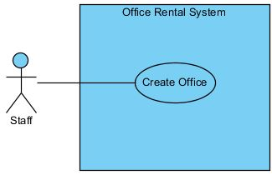

Figure : <Staff> Create Office

**Use Case Specification**

|  |  |  |  |  |
| --- | --- | --- | --- | --- |
| **USE CASE – CREATE OFFICE** | | | | |
| **Use-case No.** | UC037 | **Use-case Version** | | 1.0 |
| **Use-case Name** | Create Office | | | |
| **Author** | Trương Tiến Thành | | | |
| **Date** | 25/05/2015 | **Priority** | Normal | |
| **Actor:**   * Staff   **Summary:**   * This usecase allow staff to create a new office.   **Goal**:   * Staff can add new office to system.   **Triggers:**   * Click “Thêm mới văn phòng” button.   **Preconditions:**   * User logged in successfully with Staff role.   **Post Conditions:**   * **Success:** A successful message will be displayed, new office will be added. After reloaded staff page, new row of office will be display. * **Fail:** Display error message and cannot add new office to database.   **Main Success Scenario:**   |  |  |  | | --- | --- | --- | | Step | Actor Action | System Response | | 1 | Clicks “Thêm mới văn phòng” button on staff page. | Show the page with title “Thêm mới văn phòng”. The create office page includes:   * Tên văn phòng: Text box (Name, length [3, 50], required)   [Exception 2]   * Địa chỉ: Text box (Address, min length: 6, required) * Quận: Drop down list (District, required) * Hình ảnh: Button (Image] * Mô tả văn phòng: Text area (Description, length [3, 500], required)   [Exception 3]   * Giá thuê: Text box (Price, type number, required)   [Exception 4]   * Đơn vị giá: Drop down list (PriceTerm, require) * Số tầng: Text box (Floor, type number, required)   [Exception 5]   * Loại văn phòng: Drop down list (Category, required) * Tiện ích: Check box (Amenity) * Tổng diện tích: Text box (Area, type number, min: 50, required)   [Exception 6, 7]   * Tạo mới: button   [Exception 1, 8]   * Hủy: button | | 2 | Inputs information into all fields and clicks “Tạo mới” button.  [Alternative 1] | Show successfully message: “Đã thêm thành công văn phòng!” and redirect to staff page. |   **Alternative Scenario:**   |  |  |  | | --- | --- | --- | | No | Actor Action | System Response | | 1 | Staff clicks “Hủy” button. | The data in all fields will be reset and redirect to staff page. |   **Exceptions:**   |  |  |  | | --- | --- | --- | | No | Actor Action | System Response | | 1 | “Tên văn phòng”, “Địa chỉ”, “Hình ảnh”, “Trạng thái”, “Mô tả văn phòng”, “Giá thuê”, “Đơn vị giá”, “Số tầng”, “Loại văn phòng”, “Tiện ích”, “Tổng diện tích” are empty. | Shows error message “Vui lòng nhập đầy đủ thông tin yêu cầu!” | | 2 | Name is less than 3 characters or more than 50 characters. | Shows error message “Tên văn phòng từ 3 đến 50 ký tự!”. | | 3 | Description is less than 3 characters or more than 500 characters. | Shows error message “Mổ tả văn phòng từ 3 đến 500 ký tự!”. | | 4 | Price is not a number. | Shows error message “Giá thuê không hợp lệ!” | | 5 | Floor is not a number. | Shows error message “Số tầng không hợp lệ!” | | 6 | Area is smaller than 50. | Shows error message “Tổng diện tích tối thiểu cho thuê là 50m2!” | | 7 | Area is not a number. | Shows error message “Tổng diện tích không hợp lệ!” | | 8 | Cannot create new office | Shows error message “Không thể thêm mới văn phòng. Vui lòng thử lại sau” | | 9 |  |  |   **Relationships:** View Office Detail  **Business Rules:**   * When select office type “Văn phòng nguyên căn”, the price term available “Nguyên căn” and “Liên hệ”, while type “Tòa nhà văn phòng”, the price term available: “/m2” , “/người”, and “Liên hệ” * Staffs can add new office to system when there is a new office for lease contact with us. * Office name should be different from existed office of system. * Office information should be clearly and correctly. | | | | |

Table : <Staff>Create Office

##### <Staff>View Assigned Repair Request

**Use Case Diagram**

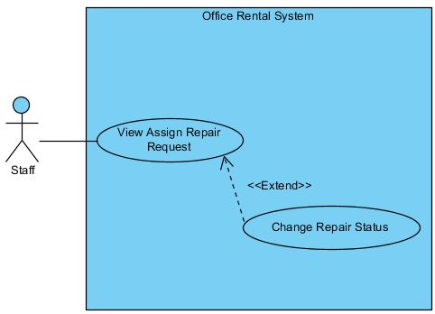

Figure : <Staff>View Assigned Repair Request

**Use Case Specification**

|  |  |  |  |
| --- | --- | --- | --- |
| **USE CASE VIEW ASSIGNED REPAIR REQUEST** | | | |
| **Use Case No.** | UC038 | **Use Case Version** | 1.0 |
| **Use Case Name** | View Assigned Repair Request | | |
| **Author** | Trương Tiến Thành | | |
| **Date** | 28/05/2015 | **Priority** | High |
| **Actor:**   * Staff   **Summary:**   * This use case allows staff to view task repairing that manager assign after customers request.   **Goal:**   * Staff can view task repairing.   **Triggers:**   * Click “Xem công việc” in menu. * Choose “Sửa chữa” in drop down menu.   **Preconditions:**   * User must log in the system with Staff role.   **Post Conditions:**   * **Success:** Display repair request. * **Fail:** Cannot load repair request.   **Main Success Scenario:**   |  |  |  | | --- | --- | --- | | Step | Actor Action | System Response | | 1 | Choose “Sửa chữa” in drop down menu at staff page. | Display all repair request with status in repairing page.  [Alternative 1] [Exception 1] |   **Alternative Scenario:**   |  |  |  | | --- | --- | --- | | No | Actor Action | System Response | | 1 | Choose “Sửa chữa” in drop down menu at staff page. | Display message: “Không có yêu cầu sửa chữa nào.” |   **Exceptions:**   |  |  |  | | --- | --- | --- | | No | Actor Action | System Response | | 1 | Cannot view repair request due to database connection. | Display error message: “Không thể tải yêu cầu sửa chữa. Vui lòng thử lại sau.” |   **Relationships:** Change Repair Status  **Business Rules:**   * List of repair request is sorted by status with the status “Incomplete” on top of list. | | | |

Table : <Staff>View Assigned Repair Request

##### <Staff>Change Repair Status

**Use Case Diagram**

**

Figure : <Staff>Change Repair Status

**Use Case Specification**

|  |  |  |  |
| --- | --- | --- | --- |
| **USE CASE CHANGE REPAIR STATUS** | | | |
| **Use Case No.** | UC039 | **Use Case Version** | 1.0 |
| **Use Case Name** | Change Repair Status | | |
| **Author** | Trương Tiến Thành | | |
| **Date** | 28/05/2015 | **Priority** | High |
| **Actor:**   * Staff   **Summary:**   * This use case allows staff to change status of request when they finish repair.   **Goal:**   * Staff can change status after they complete task repairing. * Staff change status from incomplete to complete.   **Triggers:**   * Click “Xem công việc” in menu. * Choose “Sửa chữa” in drop down menu. * Click “Hoàn thành” button.   **Preconditions:**   * User must log in the system with Staff role. * At least there is one request repair from customer.   **Post Conditions:**   * **Success:** Repair request’s status is changed to “Hoàn thành”. * **Fail:** Repair request’s status isn’t updated in database.   **Main Success Scenario:**   |  |  |  | | --- | --- | --- | | Step | Actor Action | System Response | | 1 | On repairing page, clicks “Hoàn thành” button next to the repair request that he/she finished. | Display message “Đã thay đổi trang thái sang hoàn thành.”  [Exception 1] |   **Alternative Scenario:** N/A  **Exceptions:**   |  |  |  | | --- | --- | --- | | No | Actor Action | System Response | | 1 | Cannot change status due to database connection. | Display error message: “Không thể thay đổi trang thái. Vui lòng thử lại sau.” |   **Relationships:** View Assigned Repair Request  **Business Rules:**   * Cannot change status “Hoàn thành” to “Chưa hoàn thành”. * Staff should notify to manager after change status. | | | |

Table : <Staff>Change Repair Status

#### <Manager> Overview Use Case

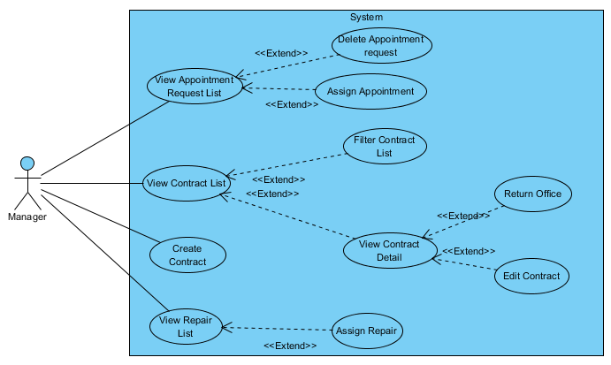

Figure : <Manager> Overview Use Case

##### <Manager> View Appointment Request List

**Use Case Diagram**

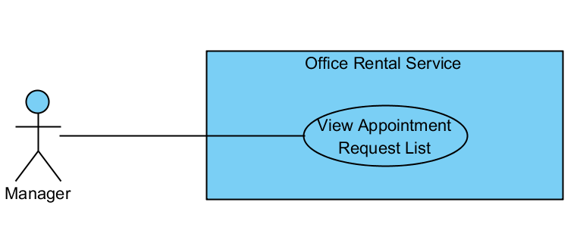

Figure : <Manager> View Appointment Request List

**Use Case Specification**

|  |  |  |  |
| --- | --- | --- | --- |
| **USE CASE VIEW APPOINTMENT REQUEST LIST** | | | |
| **Use Case No.** | UC041 | **Use Case Version** | 1.0 |
| **Use Case Name** | View Appointment Request List | | |
| **Author** | Nguyễn Vũ Hoàng Quốc | | |
| **Date** | 31/05/2015 | **Priority** | Normal |
| **Actor:**   * Manager   **Summary:**   * This use case allows manager see all appointment request   **Goal:**   * Show all appointment request   **Triggers:**   * From the menu bar:   + Select “ Appointment ” menu.   **Preconditions:**   * There are request appointment from customer * Requests from customers are valid and send successful   **Post Conditions:**   * **Success:** All appointment request are shown * **Fail:** Cannot get appointment list from database.   **Main Success Scenario:**   |  |  |  | | --- | --- | --- | | Step | Actor Action | System Response | | 1 | Click “Appointment” button on menu bar of manager role | * Show all request appointment list in which includes:   + Customer name   + Assigned staff   + Office   + Time   [Exception 1] |   **Alternative Scenario:**   |  |  |  | | --- | --- | --- | | No | Actor Action | System Response | |  | . |  |   **Exceptions:**   |  |  |  | | --- | --- | --- | | No | Actor Action | System Response | | 1 | Cannot load appointment list from database | Display error message: “Cannot get request appointment list. Please try again” |   **Relationships:** Delete Appointment request, Assign Appointment, View Customer Info  **Business Rules:**   * Manager can view all list appointment from customer’s request | | | |

Table : <Manager> View Appointment Request List

##### <Manager> Delete Appointment request

**Use Case Diagram**

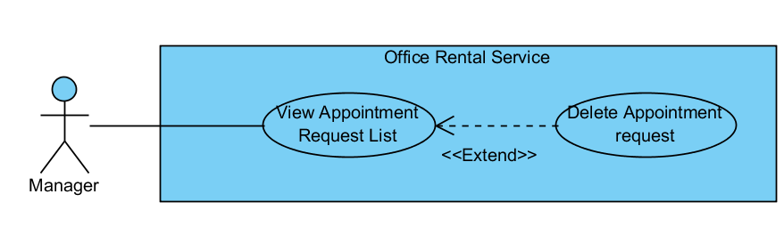

Figure : <Manager> Delete Appointment request

**Use Case Specification**

|  |  |  |  |
| --- | --- | --- | --- |
| **USE CASE DELETE APPOINTMENT REQUEST** | | | |
| **Use Case No.** | UC042 | **Use Case Version** | 1.0 |
| **Use Case Name** | Delete Appointment request | | |
| **Author** | Nguyễn Vũ Hoàng Quốc | | |
| **Date** | 31/05/2015 | **Priority** | Normal |
| **Actor:**   * Manager   **Summary:**   * This use case allows manager delete appointment request which is not suitable   **Goal:**   * Delete appointment request successful   **Triggers:**   * From the menu bar:   + Select “Appointment” menu.   + Choose appointment   + Click “Delete” button on appointment detail page   **Preconditions:**   * There are request appointment from customer * Requests from customers are valid and send successful   **Post Conditions:**   * **Success:** Appointment request is deleted successful * **Fail:** Delete error.   **Main Success Scenario:**   |  |  |  | | --- | --- | --- | | Step | Actor Action | System Response | | 1 | Click “Appointment” button on menu bar of manager role | * Show all request appointment list   [Exception 1] | | 2 | Choose the appointment in appointment list. | * Show detail of this appointment   [Exception 2] | | 3 | Click “Delete” button on appointment detail page | * Show warning popup: “Are you sure to delete this appointment?” with “Yes” and “No button” | | 4 | Click “Yes” button on warning popup  [Alternative 1] | * Show successful message: “The appointment has been deleted”   [Exception 3] |   **Alternative Scenario:**   |  |  |  | | --- | --- | --- | | No | Actor Action | System Response | | 1 | Click “No” button on warning popup | * Close warning popup |   **Exceptions:**   |  |  |  | | --- | --- | --- | | No | Actor Action | System Response | | 1 | Cannot load appointment list from database | Display error message: “Cannot get request appointment list. Please try again” | | 2 | Cannot get detail of chosen appointment from database | Display error message: “Cannot get data this appointment. Please try again” | | 3 | Delete error | Display error message: “Cannot delete this appointment. Please try again” |   **Relationships:** Appointment Request List  **Business Rules:**   * Manager can delete appointment from customer’s request if there are some error with customer’s error. * When delete, system will send email to customer’s mail. | | | |

Table : <Manager> Delete Appointment request

##### <Manager> Assign Appointment

**Use Case Diagram**

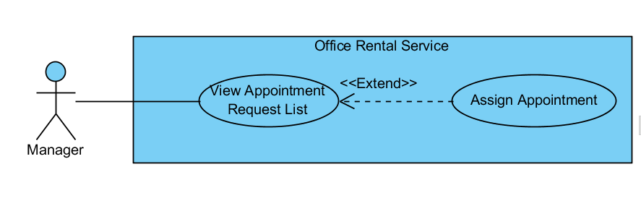

Figure : <Manager> Assign Appointment

**Use Case Specification**

|  |  |  |  |
| --- | --- | --- | --- |
| **USE CASE ASSIGN APPOINTMENT** | | | |
| **Use Case No.** | UC043 | **Use Case Version** | 1.0 |
| **Use Case Name** | Assign Appointment | | |
| **Author** | Nguyễn Vũ Hoàng Quốc | | |
| **Date** | 31/05/2015 | **Priority** | Normal |
| **Actor:**   * Manager   **Summary:**   * This use case allows manager assign appointment request to staff   **Goal:**   * Assign appointment to staff successful   **Triggers:**   * From the menu bar:   + Select “Appointment” menu.   + Choose appointment   + Click “Assign” button on appointment detail page   + Choose staff in staff list   + Click “Assign” button on staff list   **Preconditions:**   * There are request appointment from customer * Requests from customers are valid and send successful * Manager checked the appointment is suitable   **Post Conditions:**   * **Success:** Appointment request is assign successful * **Fail:** Assign error.   **Main Success Scenario:**   |  |  |  | | --- | --- | --- | | Step | Actor Action | System Response | | 1 | Click “Appointment” button on menu bar of manager role | * Show all request appointment list   [Exception 1] | | 2 | Choose the appointment in appointment list. | * Show detail of this appointment   [Exception 2] | | 3 | Click “Assign” button on appointment detail page | * Show list of staffs | | 4 | Choose staff in staff list  [Alternative 1] | * Show “checked” at staff was chosen | | 5 | Click “Assign” button on list staff | * Show success message: “Assign successful”   [Exception 3] |   **Alternative Scenario:**   |  |  |  | | --- | --- | --- | | No | Actor Action | System Response | | 1 | Click “close” button on list staff | * Show appointment detail page |     **Exceptions:**   |  |  |  | | --- | --- | --- | | No | Actor Action | System Response | | 1 | Cannot load appointment list from database | Display error message: “Cannot get request appointment list. Please try again” | | 2 | Cannot get detail of chosen appointment from database | Display error message: “Cannot get data this appointment. Please try again” | | 3 | Assign error | Display error message: “Cannot assign this appointment to staff. Please try again” |   **Relationships:** Appointment Request List  **Business Rules:**   * Manager can assign appointment from customer’s request to staff if the request is suitable. * When assign, system will send email to staff’ and add the request to staff’s task list. | | | |

Table : <Manager> Assign Appointment

##### <Manager> View Customer Info

**Use Case Diagram**

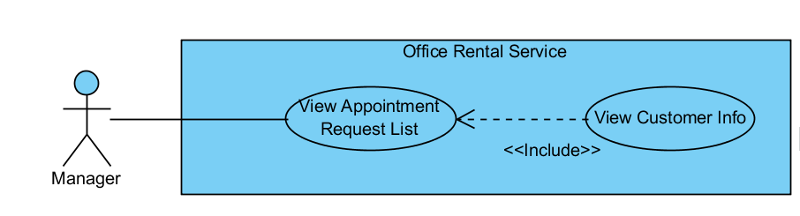

Figure : <Manager> View Customer Info

**Use Case Specification**

|  |  |  |  |
| --- | --- | --- | --- |
| **USE CASE VIEW CUSTOMER INFO** | | | |
| **Use Case No.** | UC044 | **Use Case Version** | 1.0 |
| **Use Case Name** | View Customer Info | | |
| **Author** | Nguyễn Vũ Hoàng Quốc | | |
| **Date** | 31/05/2015 | **Priority** | Normal |
| **Actor:**   * Manager   **Summary:**   * This use case allows manager view customer info from appointment list   **Goal:**   * View customer profile   **Triggers:**   * From the menu bar:   + Select “Appointment” menu.   + Choose appointment   + Click to customer’s name in appointment detail page   **Preconditions:**   * There are request appointment from customer * Requests from customers are valid and send successful   **Post Conditions:**   * **Success:** Show customer profile * **Fail:** Cannot get data of the customer in database.   **Main Success Scenario:**   |  |  |  | | --- | --- | --- | | Step | Actor Action | System Response | | 1 | Click “Appointment” button on menu bar of manager role | * Show all request appointment list   [Exception 1] | | 2 | Choose the appointment in appointment list. | * Show detail of this appointment   [Exception 2] | | 3 | Click to name of customer in appointment detail page | * Show customer profile includes:   + Username   + Email   + Phone   + Address   [Exception 3] |   **Alternative Scenario:**   |  |  |  | | --- | --- | --- | | No | Actor Action | System Response | |  |  |  |     **Exceptions:**   |  |  |  | | --- | --- | --- | | No | Actor Action | System Response | | 1 | Cannot load appointment list from database | Display error message: “Cannot get request appointment list. Please try again” | | 2 | Cannot get detail of chosen appointment from database | Display error message: “Cannot get data this appointment. Please try again” | | 3 | Cannot get detail of chosen customer from database | Display error message: “Cannot get data this customer. Please try again” |   **Relationships:** Appointment Request List  **Business Rules:**   * Manager can find customer profile base on appointment request list | | | |

Table : <Manager> View Customer Info

##### <Manager> View Contract List

**Use Case Diagram**

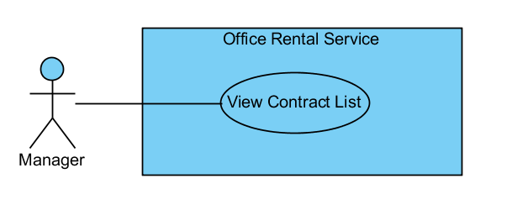

Figure : <Manager> View Contract List

**Use Case Specification**

|  |  |  |  |
| --- | --- | --- | --- |
| **USE CASE VIEW CONTRACT LIST** | | | |
| **Use Case No.** | UC045 | **Use Case Version** | 1.0 |
| **Use Case Name** | View Contract List | | |
| **Author** | Nguyễn Vũ Hoàng Quốc | | |
| **Date** | 31/05/2015 | **Priority** | Normal |
| **Actor:**   * Manager   **Summary:**   * This use case allows manager view contract list   **Goal:**   * Show all contract list   **Triggers:**   * From the menu bar:   + Select “Contract” menu.   **Preconditions:**   * Login as manager role   **Post Conditions:**   * **Success:** Show all contracts in database * **Fail:** Cannot get data of the contract in database.   **Main Success Scenario:**   |  |  |  | | --- | --- | --- | | Step | Actor Action | System Response | | 1 | Click “Contract” button on menu bar of manager role | * Show all contract in list   [Exception 1] |   **Alternative Scenario:**   |  |  |  | | --- | --- | --- | | No | Actor Action | System Response | |  |  |  |     **Exceptions:**   |  |  |  | | --- | --- | --- | | No | Actor Action | System Response | | 1 | Cannot load contract list from database | Display error message: “Cannot get contract list. Please try again” |   **Relationships:** Contract  **Business Rules:**   * Only manager can see all contracts in database | | | |

Table : <Manager> View Contract List

##### <Manager> View Contract Detail

**Use Case Diagram**

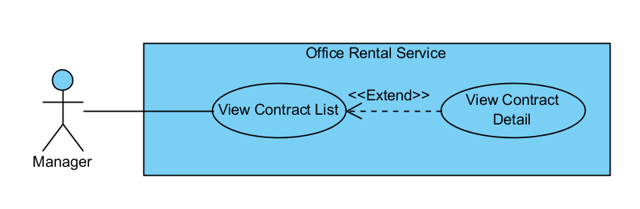

Figure : <Manager> View Contract Detail

**Use Case Specification**

|  |  |  |  |
| --- | --- | --- | --- |
| **USE CASE VIEW CONTRACT DETAIL** | | | |
| **Use Case No.** | UC046 | **Use Case Version** | 1.0 |
| **Use Case Name** | View Contract Detail | | |
| **Author** | Nguyễn Vũ Hoàng Quốc | | |
| **Date** | 31/05/2015 | **Priority** | Normal |
| **Actor:**   * Manager   **Summary:**   * This use case allows manager view contract detail   **Goal:**   * Show contract detail   **Triggers:**   * From the menu bar:   + Select “Contract” menu.   + Choose contract in the contract list   **Preconditions:**   * Contract is not out of date   **Post Conditions:**   * **Success:** Show detail of chosen contract * **Fail:** Cannot get data of the contract in database.   **Main Success Scenario:**   |  |  |  | | --- | --- | --- | | Step | Actor Action | System Response | | 1 | Click “Contract” button on menu bar of manager role | * Show all contract in list   [Exception 1] | | 2 | Choose contract in contract list | * Show all detail of the contract includes:   + Customer name   + Office name   + Start date   + End date   + Payment fee   + Payment term   [Exception 2] |   **Alternative Scenario:**   |  |  |  | | --- | --- | --- | | No | Actor Action | System Response | |  |  |  |     **Exceptions:**   |  |  |  | | --- | --- | --- | | No | Actor Action | System Response | | 1 | Cannot load contract list from database | Display error message: “Cannot get contract list. Please try again” | | 2 | Cannot load data of the chosen contract | Display error message: “Cannot get data of this contract. Please try again” |   **Relationships:** Contract  **Business Rules:**   * Manager can see detail of the contract * The contract is still have time if not system will delete contract in database and send notification to customer | | | |

Table : <Manager> View Contract Detail

##### <Manager> Edit Contract

**Use Case Diagram**

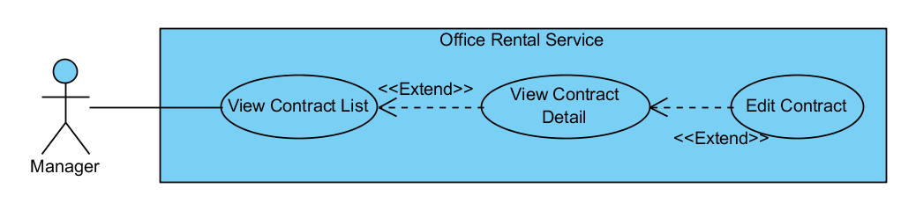

Figure : <Manager> Edit Contract

**Use Case Specification**

|  |  |  |  |
| --- | --- | --- | --- |
| **USE CASE EDIT CONTRACT** | | | |
| **Use Case No.** | UC047 | **Use Case Version** | 1.0 |
| **Use Case Name** | Edit Contract | | |
| **Author** | Nguyễn Vũ Hoàng Quốc | | |
| **Date** | 31/05/2015 | **Priority** | Normal |
| **Actor:**   * Manager   **Summary:**   * This use case allows manager edit contract   **Goal:**   * Contract is edited   **Triggers:**   * From the menu bar:   + Select “Contract” menu.   + Choose contract in the contract list   + Click “Edit” button in contract detail page   **Preconditions:**   * Contract is not out of date * There is request to change detail in contract from customer   **Post Conditions:**   * **Success:** Edit contract successful * **Fail:** Edit error   **Main Success Scenario:**   |  |  |  | | --- | --- | --- | | Step | Actor Action | System Response | | 1 | Click “Contract” button on menu bar of manager role | * Show all contract in list   [Exception 1] | | 2 | Choose contract in contract list | * Show all detail of the contract   + Customer name   + Office name   + Start date   + End date   + Payment fee   + Payment term   [Exception 2] | | 3 | Click “Edit” button on contract detail page | * Show input text for edit * Show “save” and “cancel” button | | 4 | Input or edit field on contract detail page | * Validate input show error if data invalid   [Exception 3] | | 5 | Click “Save” button on contract  [Alternative 1] | * Show successful message |   **Alternative Scenario:**   |  |  |  | | --- | --- | --- | | No | Actor Action | System Response | | 1 | Click “cancel” button | * Show “Edit” button, hide “save” and “cancel” button |     **Exceptions:**   |  |  |  | | --- | --- | --- | | No | Actor Action | System Response | | 1 | Cannot load contract list from database | Display error message: “Cannot get contract list. Please try again” | | 2 | Cannot load data of the chosen contract | Display error message: “Cannot get data of this contract. Please try again” | | 3 | From date > End Date | Display error message: “From date or end date is invalid. Please check again” |   **Relationships:** Contract  **Business Rules:**   * Manager edit contract when customer need to renewal contract before contract is out of date * System will send message to customer before contract is out date 1 month * If customer want to renewal contract, manager will edit | | | |

Table : <Manager> Edit Contract

##### <Manager> Create Contract

**Use Case Diagram**

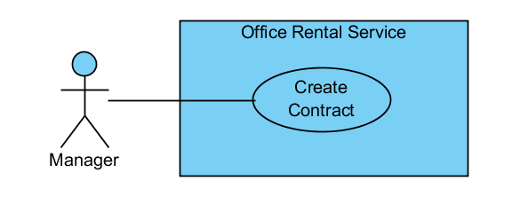

Figure : <Manager> Create Contract

**Use Case Specification**

|  |  |  |  |
| --- | --- | --- | --- |
| **USE CASE CREATE CONTRACT** | | | |
| **Use Case No.** | UC048 | **Use Case Version** | 1.0 |
| **Use Case Name** | Create Contract | | |
| **Author** | Nguyễn Vũ Hoàng Quốc | | |
| **Date** | 31/05/2015 | **Priority** | Normal |
| **Actor:**   * Manager   **Summary:**   * This use case allows manager create contract   **Goal:**   * Contract is create and add to database   **Triggers:**   * From the menu bar:   + Select “Contract” menu.   + Click “New” button on menu bar   + Click “Create” button after input info   **Preconditions:**  **Post Conditions:**   * **Success:** Contract is saved to database * **Fail:** Create fail   **Main Success Scenario:**   |  |  |  | | --- | --- | --- | | Step | Actor Action | System Response | | 1 | Click “Contract” button on menu bar of manager role | * Show all contract in list   [Exception 1] | | 2 | Click “New” button on menu bar | * Show input field for detail of the contract   + Customer name: textbox   + Office name: textbox   + Start date: calendar   + End date: calendar   + Payment fee: dropdown list   + Payment term: dropdown list | | 3 | Input info for all field | * Validate input show error if data invalid   [Exception 2] | | 4 | Click “Create” button on contract | * Show successful message |   **Alternative Scenario:**   |  |  |  | | --- | --- | --- | | No | Actor Action | System Response | |  |  |  |     **Exceptions:**   |  |  |  | | --- | --- | --- | | No | Actor Action | System Response | | 1 | Cannot load contract list from database | Display error message: “Cannot get contract list. Please try again” | | 2 | From date > End Date | Display error message: “From date or end date is invalid. Please check again” |   **Relationships:** Contract  **Business Rules:**   * Manager will meet customer after customer decide to rent office * Manager will create contract after the meeting | | | |

Table : <Manager> Create Contract

##### <Manager> Cancel Contract

**Use Case Diagram**

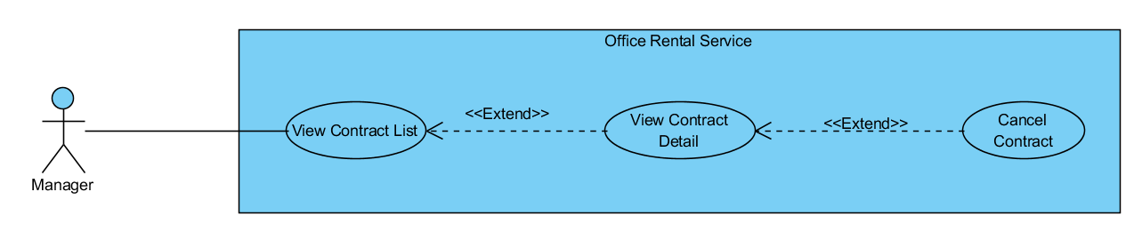

Figure : <Manager> Cancel Contract

**Use Case Specification**

|  |  |  |  |
| --- | --- | --- | --- |
| **USE CASE CANCEL CONTRACT** | | | |
| **Use Case No.** | UC049 | **Use Case Version** | 1.0 |
| **Use Case Name** | Cancel Contract | | |
| **Author** | Nguyễn Vũ Hoàng Quốc | | |
| **Date** | 31/05/2015 | **Priority** | Normal |
| **Actor:**   * Manager   **Summary:**   * This use case allows manager cancel contract   **Goal:**   * Contract is canceled and removed from database   **Triggers:**   * From the menu bar:   + Select “Hợp đồng” on menu.   + Choose a contract from contract list   + Click “Hủy hợp đồng” button on contract page detail   **Preconditions:**   * At least exist one contract in database and not expired * Have request cancel from customer   **Post Conditions:**   * **Success:** Contract is canceled and removed from database * **Fail:** Remove contract fail   **Main Success Scenario:**   |  |  |  | | --- | --- | --- | | Step | Actor Action | System Response | | 1 | Click “Hợp đồng” button on menu bar of manager role | * Show all contract in list   [Exception 1] | | 2 | Choose a contract from contract list | * Show detail of chosen contract   [Exception 2] | | 3 | Click “Hủy hợp đồng” button on contract page detail | * Show warning popup: “Bạn chắc chắn muốn huy hợp đồng này chứ?” with “Đồng ý” and “Không đồng ý” button | | 4 | Click “Đồng ý” button on warning popup  [Alternative 1] | * Show successful message: “Đã hủy hợp đồng thành công”   [Exception 3] |   **Alternative Scenario:**   |  |  |  | | --- | --- | --- | | No | Actor Action | System Response | | 1 | Click “Không đồng ý” button on warning popup | * Return to detail page of the chosen contract |     **Exceptions:**   |  |  |  | | --- | --- | --- | | No | Actor Action | System Response | | 1 | Cannot load contract list from database | Display error message: “Không lấy được dữ liệu hợp đồng. Xin vui lòng thử lại” | | 2 | Cannot get data of the chosen contract | Display error message: “Không lấy được dữ liệu của hợp đồng này. Xin vui lòng thử lại” | | 3 | Cannot delete contract from database | Display error message: “Không thể hủy hợp đồng này. Xin vui lòng thử lại” |   **Relationships:** Contract  **Business Rules:**   * Manager will meet customer after customer decide to rent office * Manager will create contract after the meeting with customer | | | |

Table : <Manager> Cancel Contract

##### <Manager> Filter Contract List

**Use Case Diagram**

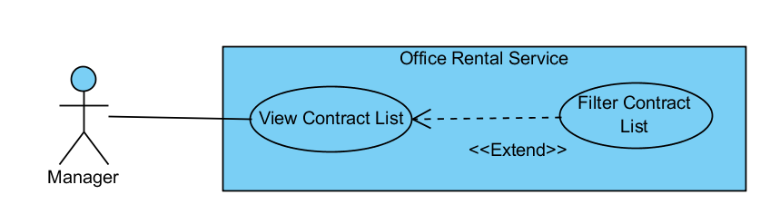

Figure : <Manager> Filter Contract List

**Use Case Specification**

|  |  |  |  |
| --- | --- | --- | --- |
| **USE CASE FILTER CONTRACT LIST** | | | |
| **Use Case No.** | UC140 | **Use Case Version** | 1.0 |
| **Use Case Name** | Filter Contract List | | |
| **Author** | Nguyễn Vũ Hoàng Quốc | | |
| **Date** | 31/05/2015 | **Priority** | Normal |
| **Actor:**   * Manager   **Summary:**   * This use case allows manager filter contract in list   **Goal:**   * Show all contract is suitable with filter   **Triggers:**   * From the menu bar:   + Select “Hợp đồng” on menu.   + Click “Tìm kiếm nâng cao” on menu bar   + Input info for filter   + Click “Tìm” button   **Preconditions:**   * At least exist one contract in database and not expired   **Post Conditions:**   * **Success:** show one or many contracts * **Fail:** Cannot find any contract   **Main Success Scenario:**   |  |  |  | | --- | --- | --- | | Step | Actor Action | System Response | | 1 | Click “Hợp đồng” button on menu bar of manager role | * Show all contract in list   [Exception 1] | | 2 | Click “Tìm kiếm nâng cao” on menu bar | * Show input field for filter:   + City: dropdown list   + District: dropdown list   + Office: textbox   [Exception 2] | | 3 | Input info for filter | * Validate info | | 4 | Click “Tìm” button | * Show list of contract which is suitable which filter info   [Exception 3] |   **Alternative Scenario:**   |  |  |  | | --- | --- | --- | | No | Actor Action | System Response | |  |  |  |     **Exceptions:**   |  |  |  | | --- | --- | --- | | No | Actor Action | System Response | | 1 | Cannot load contract list from database | Display error message: “Không lấy được dữ liệu hợp đồng. Xin vui lòng thử lại” | | 2 | Office name not exist in database | Display error message: “Văn phòng này không tồn tại” | | 3 | Cannot filter contract | Display error message: “Không tìm được bất kỳ hợp đồng nào. Xin vui lòng thử lại” |   **Relationships:** Contract  **Business Rules:**   * Manager manages many contracts. So they can filter which contract base on city, district or office to make them easy to manage. | | | |

Table : <Manager> Filter Contract List

##### <Manager> View Repair List

**Use Case Diagram**

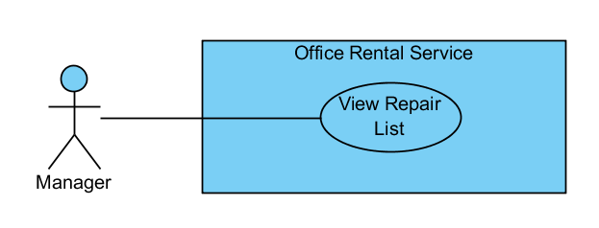

Figure : <Manager> View Repair List

**Use Case Specification**

|  |  |  |  |
| --- | --- | --- | --- |
| **USE CASE VIEW REPAIR LIST** | | | |
| **Use Case No.** | UC141 | **Use Case Version** | 1.0 |
| **Use Case Name** | View Repair List | | |
| **Author** | Nguyễn Vũ Hoàng Quốc | | |
| **Date** | 31/05/2015 | **Priority** | Normal |
| **Actor:**   * Manager   **Summary:**   * This use case allows manager see all repair requests   **Goal:**   * Show all repair request   **Triggers:**   * From the menu bar:   + Select “ Sửa chữa ” on the menu.   **Preconditions:**   * At lease exist one repair request in database   **Post Conditions:**   * **Success:** All request repair are shown * **Fail:** Cannot get repair list from database.   **Main Success Scenario:**   |  |  |  | | --- | --- | --- | | Step | Actor Action | System Response | | 1 | Click “Sửa chữa” button on menu bar of manager role | * Show all repair requests list in which includes:   + ContractID: text   + Assigned staff: text   + Type: dropdown list   + Description: text   [Exception 1] | |  |  |  |   **Alternative Scenario:**   |  |  |  | | --- | --- | --- | | No | Actor Action | System Response | |  | . |  |   **Exceptions:**   |  |  |  | | --- | --- | --- | | No | Actor Action | System Response | | 1 | Cannot load repair request list from database | Display error message: “Không lấy được dữ liệu toàn bộ yêu cầu sửa chữa. Xin vui lòng thử lại” |   **Relationships:** Request repair  **Business Rules:**   * Manager can view all request repair for assigning to staff | | | |

Table : <Manager> View Repair List

##### <Manager> Assign Repair

**Use Case Diagram**

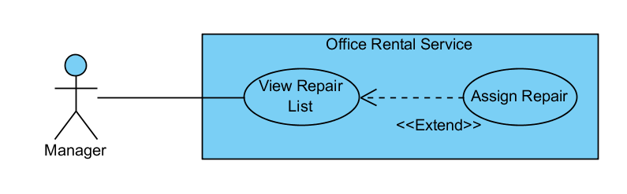

Figure : <Manager> Assign Repair

**Use Case Specification**

|  |  |  |  |
| --- | --- | --- | --- |
| **USE CASE ASSIGN REPAIR** | | | |
| **Use Case No.** | UC142 | **Use Case Version** | 1.0 |
| **Use Case Name** | Assign Repair | | |
| **Author** | Nguyễn Vũ Hoàng Quốc | | |
| **Date** | 31/05/2015 | **Priority** | Normal |
| **Actor:**   * Manager   **Summary:**   * This use case allows manager assign repair request to staff   **Goal:**   * The repair request is assigned to staff.   **Triggers:**   * From the menu bar:   + Select “Sửa chữa” on the menu.   + Select repair request on repair list   + Click  “Giao việc” button on repair request detail page   + Choose staff in staff list   + Click “Giao” button   **Preconditions:**   * At lease exist one repair request in database   **Post Conditions:**   * **Success:** The request has been assigned to staff and added to staff task list * **Fail:** Cannot assign to staff.   **Main Success Scenario:**   |  |  |  | | --- | --- | --- | | Step | Actor Action | System Response | | 1 | Click “Sửa chữa” button on menu bar of manager role | * Show all repair requests list in which includes:   + ContractID: text   + Assigned staff: text   + Type: dropdown list   + Description: text   [Exception 1] | | 2 | Select repair request on repair list | * Show detail of the chosen repair request includes:   + ContractID: text   + Assigned staff: text   + Type: dropdown list   + Description: text   + Time: text   [Exception 2] | | 3 | Click  “Giao việc” button on repair request detail page | * Show list of staff includes:   + Staff name: text   + Email: text   + Phone: text   + Address: text   + “Giao” and “Hủy” button   [Exception 3] | | 4 | Choose staff in staff list | * Show staff whom was chosen in textarea | | 5 | Click  “Giao” button  [Alternative 1] | * Show success message: “Yêu cầu sửa chữa đã được giao cho nhân viên”   [Exception 4]   * Add repair request to staff’s task   [Exception 5] |   **Alternative Scenario:**   |  |  |  | | --- | --- | --- | | No | Actor Action | System Response | | 1 | Click “Hủy” button | -Close staff list and show the chosen repair request detail page |   **Exceptions:**   |  |  |  | | --- | --- | --- | | No | Actor Action | System Response | | 1 | Cannot load repair request list from database | Display error message: “Không lấy được dữ liệu toàn bộ yêu cầu sửa chữa. Xin vui lòng thử lại” | | 2 | Cannot load repair request detail | Display error message: “Không lấy được dữ liệu yêu cầu này. Xin vui lòng thử lại” | | 3 | Cannot load list of staffs | Display error message: “Không lấy được dữ liệu toàn bộ nhân viên. Xin vui lòng thử lại” | | 4 | Cannot assign to staff | Display error message: “Không lấy được giao yêu cầu cho nhân viên. Xin vui lòng thử lại” | | 5 | Cannot add repair request to staff’s task | Display error message: “Lưu yêu cầu sửa chữa không thành công. Xin vui lòng thử lại” |   **Relationships:** Request repair  **Business Rules:**   * Manager can assign repair request to staff and this request save to task list of staff | | | |

Table : <Manager> Assign Repair

#### <Admin> Overview Use Case

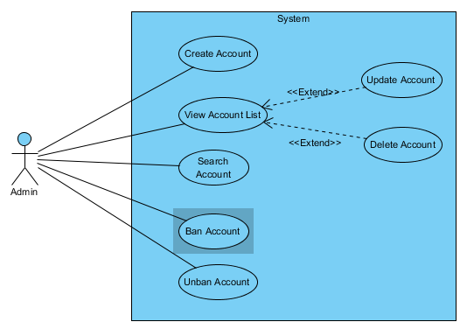

Figure : <Admin> Overview Use Case

##### <Admin> Create Account

**Use Case Diagram**

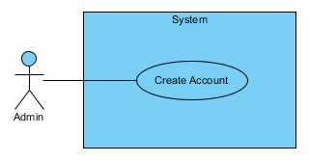

Figure : <Admin> Create Account

**Use Case Specification**

|  |  |  |  |
| --- | --- | --- | --- |
| **USE CASE - CREATE ACCOUNT** | | | |
| **Use Case No.** | UC051 | **Use Case Version** | 1.0 |
| **Use Case Name** | Create Account | | |
| **Author** | Lê Xuân Tiến | | |
| **Date** | 01/06/2015 | **Priority** | Normal |
| **Actor:**   * Admin   **Summary:**   * This use case allows admin create new account   **Goal:**   * New account is created   **Triggers:**   * From the left menu:   + Select “Người dùng” menu.   + In main screen, select “Tạo người dùng mới”   **Preconditions:**   * User must log in as Admin role * An valid email should be existed for each account   **Post Conditions:**   * **Success:** An account is created * **Fail:** Nothing is created   **Main Success Scenario:**   |  |  |  | | --- | --- | --- | | Step | Actor Action | System Response | | 1 | Click “Tạo người dùng mới” button on “Quản lí người dùng” page | - Show the create new account with following fields:  + “Username”: text box, username of the account, unique, required, min 6 characters, max 25 characters  + “Password”: text box, password of the account, required, min 6 characters, max 25 characters  + “Email”: text box, valid email of the account, required, unique  + “Role”: drop down box, include role: “Manager”, “Staff”, “Customer”  + “Lưu”: button  + “Hủy”: button | | 2 | Enter information | Validate information [Exception 1, 2, 3, 4] | | 3 | Click “Lưu” | Display success message [Exception 5] |   **Alternative Scenario:**   |  |  |  | | --- | --- | --- | | No | Actor Action | System Response | | 1 | Click “Hủy” | Go back to “Quản lí người dùng” page |   **Exceptions:**   |  |  |  | | --- | --- | --- | | No | Actor Action | System Response | | 1 | The field “Username”, “Password”, “Email” is null | Display error message: “Không được để trống trường này” | | 2 | The field “Username”, “Password” length not match | Display error message: “Yêu cầu từ 6-25 kí tự” | | 3 | The field “Email” is not a valid email | Display error message: “Email không hợp lệ” | | 4 | The field “Username”, “Email” is existed | Display error message: “Username đã tồn tại” or “Email đã tồn tại” | | 5 | Cannot load save due to database connection error | Display error message: “Có lỗi xảy ra, xin thử lại” |   **Relationships:** View account list  **Business Rules:**   * The “Manager” and “Staff” role only can be created by this function * The Account must go to their email to confirm before can log in to website | | | |

Table : <Admin> Create Account

##### <Admin> View Account List

**Use Case Diagram**

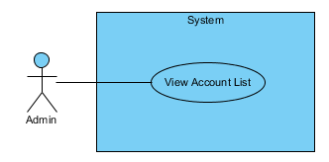

Figure : <Admin> View Account List

**Use Case Specification**

|  |  |  |  |
| --- | --- | --- | --- |
| **USE CASE – VIEW ACCOUNT LIST** | | | |
| **Use Case No.** | UC052 | **Use Case Version** | 1.0 |
| **Use Case Name** | View Account List | | |
| **Author** | Lê Xuân Tiến | | |
| **Date** | 01/06/2015 | **Priority** | Normal |
| **Actor:**   * Admin   **Summary:**   * This use case allows admin view account list   **Goal:**   * The list of account of system is displayed   **Triggers:**   * From the left menu:   + Select “Người dùng” menu.   **Preconditions:**   * User must log in as Admin role   **Post Conditions:**   * **Success:** The list of account is displayed * **Fail:** An error message is displayed   **Main Success Scenario:**   |  |  |  | | --- | --- | --- | | Step | Actor Action | System Response | | 1 | Click “Người dùng” from the menu | - Show the table of account, each page of 20 user, each line include information  + “Username”  + “Email”  + “Role” [Exception 1]  + “Xóa”: button  + “Sửa”: button  - “Tạo mới người dùng” button |   **Alternative Scenario:**   |  |  |  | | --- | --- | --- | | No | Actor Action | System Response | |  |  |  |   **Exceptions:**   |  |  |  | | --- | --- | --- | | No | Actor Action | System Response | | 1 | Cannot load load due to database connection error | Display error message: “Có lỗi xảy ra, xin thử lại” |   **Relationships:** Delete account, Update account  **Business Rules:**   * The accounts is sort by role, and then by username | | | |

Table : <Admin> View Account List

##### <Admin> Delete Account

**Use Case Diagram**

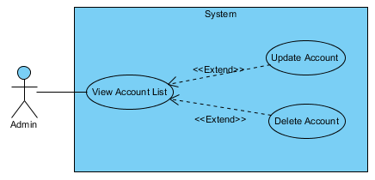

Figure : <Admin> Delete Account

**Use Case Specification**

|  |  |  |  |
| --- | --- | --- | --- |
| **USE CASE – DELETE ACCOUNT** | | | |
| **Use Case No.** | UC053 | **Use Case Version** | 1.0 |
| **Use Case Name** | Delete Account | | |
| **Author** | Lê Xuân Tiến | | |
| **Date** | 01/06/2015 | **Priority** | Normal |
| **Actor:**   * Admin   **Summary:**   * This use case allows admin delete an account   **Goal:**   * The account is marked as delete and cannot login   **Triggers:**   * From the left “Quản lí người dùng” page:   + Click “Xóa” on an account   **Preconditions:**   * User must log in as Admin role * There is accounts existed on the system   **Post Conditions:**   * **Success:** The account status is deleted * **Fail:** An error message is displayed   **Main Success Scenario:**   |  |  |  | | --- | --- | --- | | Step | Actor Action | System Response | | 1 | Click “Xóa” from an account | - Display the dialog message: “Bạn có muốn xóa người dùng này” with “Có” and “Không” button | | 2 | Click “Có” | The account is remove from the current account list [Exception 1] |   **Alternative Scenario:**   |  |  |  | | --- | --- | --- | | No | Actor Action | System Response | | 1 | Click “Không” | The previous view is display unchanged |   **Exceptions:**   |  |  |  | | --- | --- | --- | | No | Actor Action | System Response | | 1 | Cannot remove account due to database connection error | Display error message: “Có lỗi xảy ra, xin thử lại” |   **Relationships:** View account list  **Business Rules:**   * The account after deleted is mark as status deleted but not delete from database completely | | | |

Table : <Admin> Delete account

##### <Admin> Update Account

**Use Case Diagram**



Figure 43: <Admin> Update Account

**Use Case Specification**

|  |  |  |  |
| --- | --- | --- | --- |
| **USE CASE – UPDATE ACCOUNT** | | | |
| **Use Case No.** | UC054 | **Use Case Version** | 1.0 |
| **Use Case Name** | Delete Account | | |
| **Author** | Lê Xuân Tiến | | |
| **Date** | 01/06/2015 | **Priority** | Normal |
| **Actor:**   * Admin   **Summary:**   * This use case allows admin update an account   **Goal:**   * The account information is updated   **Triggers:**   * From the left “Quản lí người dùng” page:   + Click “Update” on an account   **Preconditions:**   * User must log in as Admin role * There is accounts existed on the system   **Post Conditions:**   * **Success:** The account status is update with new information * **Fail:** The account is unchanged   **Main Success Scenario:**   |  |  |  | | --- | --- | --- | | Step | Actor Action | System Response | | 1 | Click “Update” from the an account | - Display the current account’s information include:  + “Username”: text field, cannot change  + “Password”: text box, password of the account, required, min 6 characters, max 25 characters  + “Email”: text box, valid email of the account, required, unique  + “Role”: drop down box, include role: “Manager”, “Staff”, “Customer”  + “Lưu”: button  + “Hủy”: button | | 2 | Enter information | Validate information [Exception 1, 2, 3, 4] | | 3 | Click “Lưu” | Display success message [Exception 5] |   **Alternative Scenario:**   |  |  |  | | --- | --- | --- | | No | Actor Action | System Response | | 1 | Click “Hủy” | Go back to “Quản lí người dùng” page |   **Exceptions:**   |  |  |  | | --- | --- | --- | | No | Actor Action | System Response | | 1 | The field “Password”, “Email” is null | Display error message: “Không được để trống trường này” | | 2 | The field “Password” length not match | Display error message: “Yêu cầu từ 6-25 kí tự” | | 3 | The field “Email” is not a valid email | Display error message: “Email không hợp lệ” | | 4 | The field “Email” is existed | Display error message: “Email đã tồn tại” | | 5 | Cannot load save due to database connection error | Display error message: “Có lỗi xảy ra, xin thử lại” |   **Relationships:** View account list  **Business Rules:**   * This function is used to change the login information if that information is wrongly inputted | | | |

Table 36: <Admin> Update account

##### <Admin> Search Account

**Use Case Diagram**

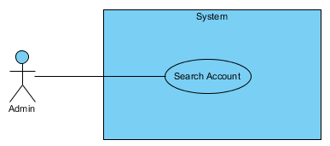

Figure 44: <Admin> Search Account

**Use Case Specification**

|  |  |  |  |
| --- | --- | --- | --- |
| **USE CASE – SEARCH ACCOUNT** | | | |
| **Use Case No.** | UC055 | **Use Case Version** | 1.0 |
| **Use Case Name** | Search Account | | |
| **Author** | Lê Xuân Tiến | | |
| **Date** | 01/06/2015 | **Priority** | Normal |
| **Actor:**   * Admin   **Summary:**   * This use case allows admin search for account(s)   **Goal:**   * The list of account of system is filtered by the search citeria   **Triggers:**   * From the left “Quản lí người dùng” page:   + Click “Search” on top of the user list   **Preconditions:**   * User must log in as Admin role * There is accounts existed on the system   **Post Conditions:**   * **Success:** The account list is filtered with the inputted information * **Fail:** An error message is shown   **Main Success Scenario:**   |  |  |  | | --- | --- | --- | | Step | Actor Action | System Response | | 1 | From the “Quản lí người dùng” page | - Display the filter information includes:  + “Role”: Drop down box, include “Customer”, “Manager”, “Staff”, “Tất cả”  + “Username”: text box, max 25 characters  + “Email”: text box  + “Lọc”: button  + “Đặt lại”: button | | 2 | Enter information and click “Lọc” | The account list is filter with all the entered information [Exception 1] |   **Alternative Scenario:**   |  |  |  | | --- | --- | --- | | No | Actor Action | System Response | | 1 | Click “Đặt lại” | The account list is reset to original state |   **Exceptions:**   |  |  |  | | --- | --- | --- | | No | Actor Action | System Response | | 5 | Cannot filter accounts due to database connection error | Display error message: “Có lỗi xảy ra, xin thử lại” |   **Relationships:** View account list  **Business Rules:**   * The inputted information should be a part of username, email so the accounts can be found | | | |

Table 37: <Admin> Update account

##### <Admin> Ban Account

**Use Case Diagram**

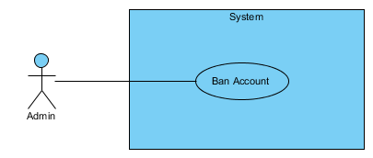

Figure 45: <Admin> Ban Account

**Use Case Specification**

|  |  |  |  |
| --- | --- | --- | --- |
| **USE CASE – BAN ACCOUNT** | | | |
| **Use Case No.** | UC056 | **Use Case Version** | 1.0 |
| **Use Case Name** | Ban Account | | |
| **Author** | Lê Xuân Tiến | | |
| **Date** | 01/06/2015 | **Priority** | Normal |
| **Actor:**   * Admin   **Summary:**   * This use case allows admin ban an account   **Goal:**   * The account is banned and get a message when login   **Triggers:**   * From the any account detail page:   + Click “Chặn người dùng”   **Preconditions:**   * User must log in as Admin role * There is accounts existed on the system * The account status is normal   **Post Conditions:**   * **Success:** The account status is banned * **Fail:** An error message is displayed   **Main Success Scenario:**   |  |  |  | | --- | --- | --- | | Step | Actor Action | System Response | | 1 | Click “Chặn người dùng” from the account detail page | - Display the dialog message: “Bạn có muốn chặn người dùng này” with “Có” and “Không” button | | 2 | Click “Có” | The account is marked as ban status, and the button on the account detail is display as “Bỏ chặn người dùng” [Exception 1] |   **Alternative Scenario:**   |  |  |  | | --- | --- | --- | | No | Actor Action | System Response | | 1 | Click “Không” | The account state unchanged |   **Exceptions:**   |  |  |  | | --- | --- | --- | | No | Actor Action | System Response | | 1 | Cannot ban account due to database connection error | Display error message: “Có lỗi xảy ra, xin thử lại” |   **Relationships:** View account list, View account detail  **Business Rules:**   * The normal flow should be from any page that has link to account detail page, then the admin can ban account that spoiled the system * When an account banned from the system login, a message is displayed “Bạn đã bị chặn khỏi hệ thống vị spam/ thông tin sai lệch. Liên lạc với admin tại <admin email> để biết them chi tiết.” | | | |

Table 38: <Admin> Ban account

##### <Admin> Unban Account

**Use Case Diagram**

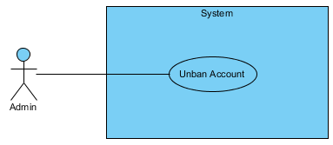

Figure 46: <Admin> Unban Account

**Use Case Specification**

|  |  |  |  |
| --- | --- | --- | --- |
| **USE CASE – UNBAN ACCOUNT** | | | |
| **Use Case No.** | UC057 | **Use Case Version** | 1.0 |
| **Use Case Name** | Unban Account | | |
| **Author** | Lê Xuân Tiến | | |
| **Date** | 01/06/2015 | **Priority** | Normal |
| **Actor:**   * Admin   **Summary:**   * This use case allows admin unban an account   **Goal:**   * The account is unban and can login normally   **Triggers:**   * From the any account detail page:   + Click “Bỏ chặn người dùng”   **Preconditions:**   * User must log in as Admin role * There is accounts existed on the system * The account status is banned   **Post Conditions:**   * **Success:** The account status is normal * **Fail:** An error message is displayed   **Main Success Scenario:**   |  |  |  | | --- | --- | --- | | Step | Actor Action | System Response | | 1 | Click “Bỏ chặn người dùng” from the account detail page | - Display the dialog message: “Bạn có muốn bỏ chặn người dùng này” with “Có” and “Không” button | | 2 | Click “Có” | The account is marked as normal status, and the button on the account detail is display as “Chặn người dùng” [Exception 1] |   **Alternative Scenario:**   |  |  |  | | --- | --- | --- | | No | Actor Action | System Response | | 1 | Click “Không” | The account state unchanged |   **Exceptions:**   |  |  |  | | --- | --- | --- | | No | Actor Action | System Response | | 1 | Cannot unban account due to database connection error | Display error message: “Có lỗi xảy ra, xin thử lại” |   **Relationships:** View account list, View account detail  **Business Rules:**   * When the user contact with admin to prove that he is not spamming or spoiling the system, or the admin ban the user by mistake, admin can use this function to recover the account | | | |

Table 39: <Admin> Unban account

## Software System Attribute

### Usability

* Staff should need less than one training week to interact with system.

### Reliability

* Information should be updated every day.

### Availability

* N/A

### Security

* All input data should be validated before saving to database.
* All privacy information, such as password, should be encrypted to ensure security.
* User should be authenticated and authorized when accessing to the system.

### Maintainability

* The system should be divided into modules and code. It would be easy to maintain and upgrade.

### Portability

* N/A

### Performance

* All requests should be response in no more than 1 minute.

## Conceptual Diagram

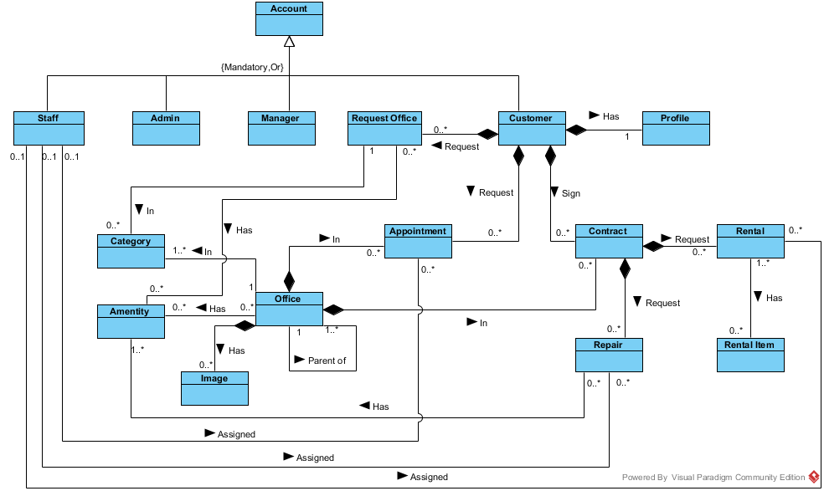

**Data dictionary:**

|  |  |
| --- | --- |
| **Entity Data dictionary: describe content of all entities** | |
| **Entity Name** | **Description** |
| Account | Describe account of user of system. |
| Staff | Describe account type staff |
| Admin | Describe account type admin |
| Manager | Describe account type manager |
| Customer | Describe account type customer |
| Profile | Describe the contact information for customer |
| Office | Describe information of the office |
| Category | Describe the category of the office |
| Amenity | Describe the amenities of the office |
| Image | List of images of the office |
| Appointment | Describe the information of the appointment of customer for the office |
| Contract | Describe the information of contract between customer and office |
| Request Office | Describe the stored office request of customer |
| Repair | Describe the repair request for each contract |
| Rental | Describe the rental request for contract |
| Rental Item | Describe the rental items which available for rental request |